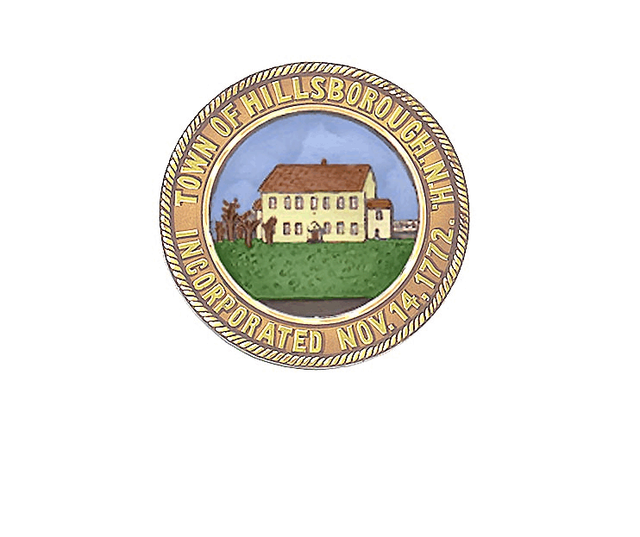
TOWN OF HILLSBOROUGH
PLANNING BOARD
27 School Street, P.O. Box 7
Hillsborough, NH 03244
(603) 464-3877 Fax (603)464-4270
E-Mail: robyn@hillsboroughnh.net
www.town.hillsborough.nh.us

May 13, 2020

PUBLIC NOTICE

Notice is hereby given in accordance with RSA 676:4 that a Site Plan Amendment application has been submitted by Sean Burt owner of “Tooky Mills Pub LLC” located at 9 Depot Street (Map 24 Lot 131). The application is for the Planning Board to approve a 24’ x 28’ expansion of the existing deck and the addition of a 7’ x 14’ stage. The application will be presented to the Hillsborough Planning Board on Wednesday, May 27, 2020, at 7:00 p.m. using the GoToMeeting Platform.

Please join the meeting from your computer, tablet or Smartphone.
https://www.gotomeet.me/Services_by_GWTS/public-hearing-tookymills-siteplan

You can also dial in using your phone.
United States +1 (408) 650-3123
Access Code: 590-152-525

Upon a finding by the Board that the application meets the submission requirements, the Board will vote to accept the application as complete and the Public Hearing on the merits of the proposal may follow immediately. Copies of the application may be viewed at the Office of Community Planning, 27 School Street, Hillsborough, New Hampshire. Anyone with questions about this application should contact Robyn Payson, Planning Director at 603-464-7971 or e-mail to robyn@hillsboroughnh.net

Hillsborough Planning Board
Case No. 2020-01

