Solid Waste Advisory Board Meeting Minutes
October 19, 2018
Board members present: Charlotte Hebert, Phil Griffin, Kim Drake, Adam VonDette, Audrey Bethel
Also present: Jon Daley, Luke Levesque, John Segedy

Meeting begins with Luke pointing out that the word “aluminum” is spelled in the alternative UK spelling on the sign that Adam a& Audrey made for the transfer station— change will be made and then it will be delivered and paper version will be made for wider distribution. Kim mentions that it will be good to add the message to crush the cans.
John Daley reports on his research on Plastic to Oil. UNH has not been responsive, although Jon still has a call in to the sustainability group on campus. A company from India that manufactures the equipment to do the process has been in contact with Jon as well.
John shared found an article that spotlights pilot plastic-to-oil programs. We decide to divvy up the list and each try to contact two. * Please note by accident Charlotte was given three because Audrey thought “Envion Geep” was all one company but it was two!
We determine the questions that we would like to ask them:
1. Are you still in operation?
2. Is your process to be economically viable/ profitable?
3. What is the approximate tonnage processed each month /or each year?
4. What obstacles did you encounter with start up (i.e. regulations, etc)
5. What is the end oil product used for?
See table pasted in for more contact info:
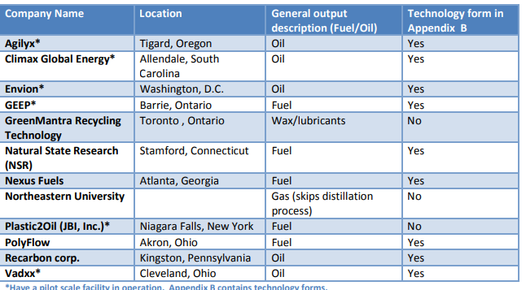

Phil-
1. Agilyx
2.Climax Global Energy
Charlotte-
1.Envion
2.Geep
3.Green Mantra Recycling
Kim-
1.Natural State Research
2.Nexus Fuels
Adam-
1.Northeastern University
2.Polyflow
Audrey –
1.Vadxx
2.Recarbon Corp.
And Jon will continue with communication with Plastic to Oil company he has already contacted.
John Segedy reports on his communication with folks at Alton transfer station – they use Waste Management for glass recycling. He does not know the cost per ton yet.
And New London is a hub center with the glass grinder but they are not taking new contracts.
Luke talks about how hard it is to get accurate info.
Casella and Waste Management … we discuss inviting a guest speaker perhaps from NRRA or Concord facility.
Luke will ask Adam Clark about coming as guest speaker?
Next Meeting is to be Nov. 16th at 7:30 am at the Hillsborough town offices.

