Town -of Hillsborough, NH

Transportation Alternatives Program (TAP) Engineering Study

For the

West Main Street Sidewalk Improvements
NHDOT Project No.: 41358

February 2019
Committee Approval: TBD Board of Selectmen Approval: TBD
NHqOT Approval: TBD

&DKuBifoijimsc.

Town of Hillsborough, NH

Transportation Alternatives Program (TAP) Engineering Study

For the

West Main Street Sidewalk Improvements
NHDOT Project No.: 41358

February 2019
Committee Approval: TBD Board of Selectmen Approval: TBD
NHDOT Approval: TBD

Prepared by:

DuBois & King, Inc.
18 Constitution Drive, Suite 8 Bedford, New Hampshire 03110

February 22, 2019
ENGINEERING • PLANNING • DEVELOPMENT • MANAGEMENT

Robyn Payson, Town Planner Town of Hillsborough
27 School Street
  - Box 7
Hillsborough, New Hampshire 03244

Subject: West Main Street Sidewalk Improvements NHDOT Project No.: 41358
Hillsborough, New Hampshire Dear Ms. Payson:
We are pleased to provide the enclosed draft Engineering Study for the West Main Street Sidewalk Improvements in Hillsborough, NH. As you are aware, this study was completed as part of the Town’s Transportation Alternatives Program (TAP) project; as administered by the New Hampshire Department of Transportation (NHDOT Project No. 41358).

As part of this study, DuBois & King met with the Town’s Sidewalk Committee, reviewed available supporting information, held a public local concerns meeting, met with NHDOT District 4 Office, and made multiple site visits to assess current conditions. In accordance with the NHDOT Local Planning Assistance (LPA) Manual, this study

    - Summarizes the project history,
    - Identifies public and NHDOT District 4 concerns,
    - Establishes a Purpose and Need,
    - Describes existing conditions,
    - Discusses current design standards,
    - Evaluates three alternatives to improve safety,
    - Prepares an opinion of probable construction for each alternative, and
    - Recommends a preferred alternative.

At your convenience, please forward this Study to Committee members for review and comment. In the meantime, if you have any questions or concerns, please do not hesitate to contact me at my office (603-637-1043) or cell phone (603-828-8788) at your convenience.
Very truly yours, DuBOIS & KING, Inc.

Scott M. Bourcier, P.E. Project Manager

SMB/smb

18 Constitution Drive, Suite 9 • Bedford, New Hampshire 03110 (603) 637-1043 (866) 783-7101 (FAX) http://www.dubois-king.com

Randolph, Vermont Springfield, Vermont South Burlington, Vermont Laconia, New Hampshire

TABLE OF CONTENTS

COVER LETTER …………….…………………………………………………………………………….  NHDOT APPROVAL LETTER ………………………………………………………………………………. | ii  iii
1.0 PROJECT DESCRIPTION …..........………………………………………………………….…………. | 1
1.1 Project History …………………………………….……………………………………………...….… | 1
1.2 Public Concerns …………………………………….…………………………………………...….… | 1
1.3 Project Purpose and Need Statement …………………………………...………………………..… | 2
2.0 EXISTING CONDITIONS …………………..........………………………………………………………. | 3
2.1 General Overview …………………………………….…………………………………..…….… | 3
2.2 Segment No. 1 ……………………….….……………………………………….…………….………. | 3
2.3 Segment No. 2 ……………………….….……………………………………….…………….………. | 3
2.4 Segment No. 3 ……………………….….……………………………………….…………….………. | 4
3.0 DESIGN STANDARDS & GUIDELINES ……………………………………………………...……. | 5
4.0 DESIGN ALTERNATIVE ANALYSIS …………………………………………………………..………. | 6
4.1 Segment No. 1 …...……………………………….………………………………………………….… | 6
4.2 Segment No. 2 …...……………………………….………………………………………………….… | 6
4.3 Segment No. 3 …...……………………………….………………………………………………….… | 6
4.4 Costs ……………...……………………………….………………………………………………….… | 7
4.5 Bituminous or Concrete Sidewalk Surface ……………………………………………………….… | 7
5.0 INTERSECTION / CROSSWALK EVALUATION ……………..……………………………..………. | 8
5.1 Intervale and Municipal Drive …...………………………………………………………………….… | 8
5.2 East Project Limit Crosswalk …................…….………………………………………………….… | 8
5.3 West Project Limit Crosswalk …................…….………………………………………………….… | 8
6.0 RIGHT-OF-WAY EVALUATION ………………………..………..……………………………..………. | 9
7.0 NATIONAL ENVIRONMENTAL POLICY ACT OF 1969 (NEPA) ………………………………….. | 10
7.1 Cultural Resources / Section 106 ……………………………………………………………………. | 10
7.2 Endangered Species ……………………………………………………………………………...…... | 10
7.3 Right of Way ………………………………………………………………………………………….... | 10
7.4 Wetland ………………………………………………………………………………..……………….. | 10
8.0 CONCLUSION & RECOMMENDATION ……………………………………………………..………... | 11
APPENDIXES
Appendix A – Concept Plans
Appendix B – Concept Typical Sections
Appendix C – Engineer’s Opinion of Probable Construction Costs Appendix D – Memorandums
Appendix E – Existing Condition Photos Appendix F – Crash Data

Town of Hillsborough, NH
West Main Street Sidewalk Improvements – Engineering Study NHDOT Project No.: 41358
D&K Project No.: 324277
(iv)

1.0 PROJECT DESCRIPTION

  - PROJECT HISTORY
In December of 1999, the Town of Hillsborough published a Master Plan with the goal of addressing the Town’s current state, including areas that needed improvement. A specific section of this publication mentions the sidewalks within the town limits. Sidewalks were described as being in fair / poor condition or non-existent; thus, making it difficult for pedestrian traffic to utilize this mode of transportation. West Main Street, its conditions and incompleteness, was used as an example for why a sidewalk improvement plan should be implemented.

In June of 2018, an updated Master Plan was proposed. The transportation section of this plan exemplified the importance of a safe and efficient transportation network. By increasing safety and efficiency within a network of sidewalks, both residence and visitors will become more welcomed to the idea of utilizing this mode of transportation. As a result, all pedestrians will have the ability to use this network for recreation, shopping, and commuting to work; all while protecting the Town’s rural character and lowering traffic volumes and emission levels. A survey performed by the Town of Hillsborough, residents were asked to identify any areas which they think sidewalks / pathways should be built. Out of the hundred twenty-seven (127) participants, eighty (80) residents identified that they feel that there should be a sidewalk built along West Main Street.

West Main Street, also known as Route 149, is an important aspect to the Town of Hillsborough’s socio- economic virtue. For years it has provided convenient access from the densely developed residential to the commercial area of the town. Although West Main Street is convenient for motorized users, it has not proven as effective for pedestrians that frequently travel this route by foot. Over the past five (5) years there have been thirteen (13) accidents reported along this stretch of road from Church Street to the Shaw’s Marketplace. Of these thirteen (13) accidents, two (2) caused injury to a pedestrian.

The need for a safer, established sidewalk system has been of high importance to not only town officials, but also many residents. In 2014, the Town of Hillsborough submitted an application to the central region Comprehensive Economic Development Strategy (CEDS) which addressed the downtown sidewalks within Hillsborough. The purpose of this CEDS study was to identify different transportation and recreation projects, town studies, etc. that are needed within a town and rank them based on how well they met the six (6) goals of the study. These six (6) goals revolved around the idea of improving infrastructure to promote business development, maintaining quality of life, and promoting the region.
The proposed project to upgrade the downtown sidewalks in Hillsborough tied for third within the Municipal Projects category in the central region.

At a Town Meeting in 2016, the residents of Hillsborough indicated their support by voting in favor a capital reserve to set aside funds for sidewalk improvements. Later that year the Hillsborough Public Works Department performed a reconstruction of an existing sidewalk on West Main Street, starting at Church Street and running 500 feet west.

Dubois & King was contracted by the Town to assist in engineering efforts to study and design sidewalk infrastructure along West Main Street from Church Street to the sidewalks located at Shaw’s Supermarket. DuBois & King’s contracted services also include construction phase services and coordination with the Town as well as the New Hampshire Department of Transportation (NHDOT) and other organizations.

This engineering study focuses on investigating the different alternatives for location and construction of this sidewalk to provide safe, reliable, and convenient access for pedestrians as stated within the ideology of the Transportation Alternatives Program (TAP), set forth by the NHDOT.

  - PUBLIC CONCERNS
The Local Concerns input was taken during two (2) meetings; first a publicly noticed meeting on September 27, 2018 and second with the NHDOT District 4 on October 11, 2018.

Town of Hillsborough, NH
West Main Street Sidewalk Improvements – Engineering Study NHDOT Project No.: 41358
D&K Project No.: 324277
(1)

During the September 27, 2018 meeting the following concerns were expressed (Minutes included in Appendix A):
    - Existing speeding issues
    - Concern for future mailbox locations
    - Sight Distance adequacy at existing crosswalk at east end of project
    - Although no existing sidewalk, pedestrians are using south side of road
    - Question about whether there would be additional street/sidewalk lighting

During the October 11, 2018 meeting the following concerns were expressed (Minutes included in Appendix A):
    - Location of crosswalks to be reviewed by NHDOT Traffic Bureau
    - Pedestrians informally crossing between Sylvania and Dunkin Donuts
    - Flat Grades/Drainage on west side of project
    - Noted discharge points to Contoocook River
    - Scheduled 2019 overlay of Road (could be postponed up to three years)
    - Clearance centerline to face of curb 16 feet preferred, 14 feet minimum.
    - ROW 4-rod West of Angus Lea, varies to the East
    - Driveway widths-50 feet max plus radii
    - Suggest truck turning evaluation of Intervale Drive
    - Snow removal-Evaluate approach, avoid snow pushed back into the road.

  - PROJECT PURPOSE and NEEDS STATEMENT

    - PROJECT PURPOSE STATEMENT
The purpose of this project is to safely convey pedestrian traffic along the West Main Street (NH Route 149) corridor in Hillsborough, NH between Edgebrook Road in the Commercial district to Church Street in the downtown (approximately a one mile corridor).

    - PROJECT NEEDS STATEMENT
The Commercial District includes some of the largest employers in town including Sylvania and Shaw’s Supermarkets as well as support local businesses such as restaurants, coffee shops, retails, and area merchants. The downtown includes municipal structures, commercial shops and is adjacent to the schools that service nearly 700 students.

Average daily traffic on West Main Street is approximately 9,500 vehicles per day (vpd) including many larger trucks. Existing roadway geometry is generally consistent with 12-foot wide travel lanes and 1-foot wide paved shoulder. The combination of high average daily traffic and limited shoulders discourages bicycle and pedestrian use along the roadway. However, connections between these areas still draws pedestrian traffic, but the safety within the segments varies significantly and becomes more challenging during the winter and early spring.

Drainage issues and erosion along the side of the road limit the ability for pedestrians to travel along the corridor outside of traffic especially in spring and winter.

The location of the corridor in relation to the schools provide potential for use for traveling to and from school, recreational use, and access to school facilities outside school hours. Discontinuities within the existing sidewalks limit its current use. Existing sidewalk widths and non-conforming ramps limit its use for people with disabilities.

The corridor crosses several intersections that could be improved with additional signage and delineation. By adding clarity for both motorized vehicles and pedestrians, the safety of these crossings could be improved.

Town of Hillsborough, NH
West Main Street Sidewalk Improvements – Engineering Study NHDOT Project No.: 41358
D&K Project No.: 324277
(2)

2.0 EXISTING CONDITIONS

  - GENERAL OVERVIEW
The Town of Hillsborough, NH is located in southern New Hampshire and is bounded by the towns of Bradford to the north; Antrim and Deering to the south, Henniker to the east, and Washington and Winsor to the west. Primary access to the town is provided by Interstate 89, US Route 202, and NH Routes 9 and 149.

Hillsborough is made up of several different residential communities as well as a single commercial district. The most densely populated residential area of Hillsborough is located on the southern edge of the town as most notably referred to as the “downtown”. The commercial district lies less than a mile west of downtown and can be accessed from downtown via Route 149 (West Main Street).

At the 2010 Census, the population of Hillsborough was reported to be approximately 6,011 people. Of the total population, approximately 4% of residents (or about 240 people) walk to work. Many of these individuals who walk work within the nearby commercial district, as it includes the four largest employers in the Town of Hillsborough; Shaw’s Supermarket, McDonalds Restaurant, Tooky Mills Restaurant, and Rite Aid Pharmacy. As a whole these companies provide employment for over 220 individuals.

West Main Street is the direct route from downtown Hillsborough to the commercial district. This roadway has a posted speed limit of 30 MPH and carries approximately 9,500 vehicles per day. The eastern boundary of this study area is to be located at the end of the newly constructed sidewalk and the western boundary of this study is to be at the location where the sidewalk begins in front of the Shaw’s Supermarket. The study area also includes both sides of the roadway along the approximately 4,500-foot long project limit; please see Figure 1 – USGS Map. This study area also abuts approximately 47 parcels, which could potentially undergo new development or redevelopment, resulting in an increased amount of pedestrian traffic.

Based upon maps provided by the NHDOT, the right-of-way limits along the easterly limits to Angus Lea Golf Course property is a 3-rod (49.5 feet). The right-of-way limits from Angus Lea Golf Course property to the westerly limits is a 4-rod (66 foot).

Pedestrians who walk along West Main Street between residential and commercial hubs have limited accessibility. Some areas along West Main Street have no sidewalk at all. The recent construction of 500 feet of new sidewalk west of Church Street along West Main Street helped address pedestrian safety concerns. However, from the point at the west end of the new sidewalk to the beginning of the existing sidewalks at the Shaw’s Supermarket, there is no continuous connection for pedestrians.

For analysis of existing conditions and alternatives the road has been broken into three segments (west to east); Segment 1 is from the east end of the sidewalk in front of Dunkin Donuts to Municipal Drive; Segment 2 is from Municipal Drive to Wall Street; and Segment 3 is from Wall Street to the west end of the new sidewalk extending to Church Street.

  - DUNKING DONUTS RESTAURANT to MUNICIPAL DRIVE (Segment 1)
Segment 1 begins on the east end of the existing sidewalk in front of Dunkin Donuts on the south side of the road. There is also about 300 feet of existing sidewalk on the south side of the road near the Municipal Drive intersection. Traveled lanes within this segment range between 11 feet and 12 feet.
Adjacent the Municipal Drive intersection the road widens to accommodate a left turn pocket. Shoulders on the south side range between 3 feet and 4 feet, but that are not always paved. Shoulders on the north side range between 1-foot and 2 feet wide. This segment is very flat and has notable drainage issues on both sides of the road.

  - MUNICIPAL DRIVE to WALL STREET (Segment 2)
Segment 2 begins with a short segment of existing sidewalk on the south side. There is a 200 foot long sidewalk on the north side of the road in front of 147 West Main Street, but it ends at an historic cemetery that is close to the road and would be an impediment to a sidewalk on that side. Lanes within this segment are typically 12-foot wide lanes. Shoulders on the south side are typically about 6 feet wide from

Town of Hillsborough, NH
West Main Street Sidewalk Improvements – Engineering Study NHDOT Project No.: 41358
D&K Project No.: 324277
(3)

Intervale Drive to the First Student bus yard. From the First Student bus yard to Dascomb Road the south shoulder is only about 1-foot wide then it resumes a width of about 5 feet wide. The north shoulder is between 1 foot and 2 feet wide throughout the corridor. The north shoulder has restricted sight distance due to trees and vertical gradient. Pedestrian travel on the north shoulder would be hazardous.

  - WALL STREET to PROJECT LIMITS (Segment 3)
Segment 3 on the south side is an existing sidewalk in poor condition. The existing roadway typical includes a 12-foot lane, 3-foot shoulder, 3-foot ditch and a slightly raised 5-foot paved sidewalk. The pavement is in poor condition but can be traversed. The sidewalk ends at the crosswalk to the new sidewalk leading East to Church Street. The North side has 12-foot lanes and shoulders that vary from 1- foot to 5 feet. The gradient of the road is steep in this section with a significant amount of water flowing to a low point near the crosswalk. Traveling the existing north shoulder would be hazardous due limited sight distance caused by foliage and the vertical curve.

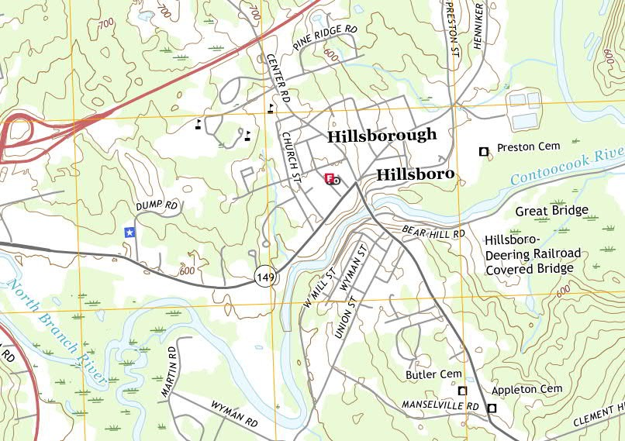
End of Sidewalk
Project Limits
Shaw’s Supermarket
Figure 1
USGS Map of Project Limits

Town of Hillsborough, NH
West Main Street Sidewalk Improvements – Engineering Study NHDOT Project No.: 41358
D&K Project No.: 324277
(4)

  - DESIGN STANDARDS and GUIDELINES

This Engineering Study proposes to follow Federal, State, Local and common industry adopted design guidelines to develop the most practicable alternative to address the project’s purpose and need. The following Federal, State, Local and common industry circulated design guidelines, standards and regulations were considered for the Project’s proposed design alternatives:

Table 3.1: Project Design Standards and Guidelines

Federal
    - 2004 AASHTO Guide for the Planning, Design and Operation of Pedestrian Facilities
    - 2018 AASHTO A Policy of Geometric Design of Highways and Streets
    - 2011 AASHTO Roadside Design Guide, 4th edition
    - 2009 FHWA Manual on Uniform Traffic Control Devices (MUTCD)
    - Americans with Disabilities Act Accessibility Guidelines (ADAAG)
    - 2011 Proposed Accessibility Guidelines for Pedestrian Facilities in the Public Right-of- Way

State
    - NHDOT Highway Design Manual, latest revision
    - NHDOT Standard Specifications for Road and Bridge Construction, 2016
    - NHDOT LPA Manual 2017
    - NHDOT Sidewalk Curb Ramp Details, 2018
    - NHDOT Standard Plans for Road Construction, 2010

Local • Town of Hillsborough, NH Town Ordinance (latest revision)

Town of Hillsborough, NH
West Main Street Sidewalk Improvements – Engineering Study NHDOT Project No.: 41358
D&K Project No.: 324277
(5)

4.0 DESIGN ALTERNATIVE ANALYSIS

  - DUNKING DONUTS RESTAURANT to MUNICIPAL DRIVE (Segment 1)

    - ALTERNATIVE No.1 – No Build
If no improvements are made pedestrians will continue to use the south shoulder and short portions of existing sidewalks to traverse this segment. Drainage issues will continue with ponding at most of the driveways and some flooding on the Sylvania property on the North. During winter months, snow and runoff ponding on the adjacent properties and the roadway will result in pedestrians using the travel-lanes.

    - ALTERNATIVE No.2 – South Side
This alternative would include shoulder, drainage, and sidewalk improvements on the south side of the roadway. There are two existing facilities on the south side that can be connected. The improvement would include a continuous sidewalk on the south side with drainage improvements and curbing.

An interim alternative could be to selectively widen the shoulders on the south side with modest drainage improvements to allow bicycles and pedestrians to more safely traverse the corridor. This would not include a separated sidewalk, but would be an improvement from the existing condition.

    - ALTERNATIVE No.3 – North Side
This alternative would include shoulder, drainage, and sidewalk improvements on the north side of the roadway. The northern alternative would require a new crosswalk at the west end of the project in order to connect to the existing facilities. There are more wetlands on the north side and removal of a large tree. There would also need to be some utility relocation in areas where the existing poles are too close to the road to allow for the new sidewalk infrastructure. There is also a higher potential for encountering hazardous material from the Sylvania site.

  - MUNICIPAL DRIVE to WALL STREET (Segment 2)

    - ALTERNATIVE No.1 – No Build
Similar to Segment No. 1, if no improvements are made pedestrians will continue to use the shoulder, drainage issues will continue with ponding at most of the driveways, and snow / runoff ponding on the adjacent properties / roadway will result in pedestrians using the travel-lanes.

    - ALTERNATIVE No.2 – South Side
The South side begins with the existing sidewalk at Intervale Drive. The ramps and detectable warning devices would need to be upgraded to meet ADA compliance. Much of this alternative has already been graded, but would require relocation of business signs, mailboxes, and some landscaping. Much of this segment falls within the area where there is a four-rod right-of-way, but negotiations with businesses will still be required. Utility relocations will be required.

    - ALTERNATIVE No.3 – North Side
The North side would require two crosswalks to connect to the existing sidewalks, has a cemetery that poses a major impediment, and would require a significant amount of clearing. There are a number of drainage issues that would need to be resolved and a series of fire hydrants that would need to be reconstructed.

  - WALL STREE to PROJECT LIMITS (Segment 3)

    - ALTERNATIVE No.1 – No Build
Same as Segments No. 1 and 2.

Town of Hillsborough, NH
West Main Street Sidewalk Improvements – Engineering Study NHDOT Project No.: 41358
D&K Project No.: 324277
(6)

    - ALTERNATIVE No.2 – South Side
South Side would reconstruct the existing sidewalk. This would require some impacts to existing fencing, mailboxes, and landscaping. There are utilities with minor conflicts on this corridor, but limited opportunities for relocation. With the exception of a few locations where the template will be restricted the existing sidewalk location can be reconstructed.

    - ALTERNATIVE No.3 – North Side
Due to the liability of leaving a sidewalk in poor condition, it was assumed that the northern alternative would also include the removal of the sidewalk along the South side of the road. The North alternative would also require tree and stump removal, mailbox and hydrant relocation, and spot utility relocation. Opportunities for a crosswalk are restricted due to limited sight distance approaching Wall Street.

  - COSTS
For comparison of approximate construction costs (not including hazardous material encountered or right- of-way easements / acquisitions) have been prepared for each segment. The below chart is a summary of the prepared cost estimate based on a combination of current bid prices of similar projects and unit weighted averages obtained by the New Hampshire Department of Transportation.

Table 4.1: Engineer’s Opinion of Probable Construction Segment Costs

 | Alt. No. 1 | Alt. No. 2 | Alt. 3
Segment 1 | $0 | $201,000 | $176,000
Segment 2 | $0 | $198,000 | $210,000
Segment 3 | $0 | $134,000 | $129,000
Total | $0 | $533,000.00 | $515,000.00

Although the cost would be difficult to estimate, the northern alternative has a greater risk of encountering hazardous materials. There was also more ponding of winter runoff on the northern side although there are stormwater issues on both sides of the road within the corridor.

  - BITUMINOUS CONCRETE or PORTLAND CEMENT CONCRETE SIDEWALK SURFACE
In this engineering study each alternative included an Engineer’s Opinion of Probable Construction Cost for a bituminous concrete surface (a.k.a. paved) or a Portland cement concrete surface (a.k.a. concrete) sidewalk. Both pavement and concrete sidewalks are acceptable and used throughout New Hampshire. New Hampshire communities have selected either a paved or concrete sidewalk based on their community’s preference. The Town of Hillsborough should determine the sidewalk surface type that best fits the Town’s goals as it relates to appearance, longevity, initial cost, and maintenance cost. Deciding the sidewalk surface should be identified prior to proceeding with the Design Phase. Table 4.2 summarizes the difference between a pavement and concrete sidewalk.

Table 4.2: Bituminous or Concrete Sidewalk Surface

Cost |  | 2 times per 2” depth per square-yard more than pavement
Durability | Less durable | More durable
Longevity | 20+ years (30+ years if resealed) | 40+ years (50+ years if resealed)
Maintenance | Resealed every 3 to 5 years to protect from oxidation and maintain elasticity | Resealed every 3 to 5 years to protect against salt corrosion
Weather Issues | Softens in high heat | Cracks in freezing temperatures
Resurfacable | Yes | No
Repairs | Easy | Difficult

Town of Hillsborough, NH
West Main Street Sidewalk Improvements – Engineering Study NHDOT Project No.: 41358
D&K Project No.: 324277
(7)

5.0 INTERSECTION / CROSSWALK EVALUATION

  - INTERVALE and MUNICIPAL DRIVE INTERSECTION
As part of this study the intersection of West Main Street with Intervale Drive and Municipal Drive were evaluated. The existing conditions of West Main Street, at both intersections, include left turn lanes for both the eastbound and westbound traffic. Intervale Drive has one lane for ingress and one for egress. Municipal Drive has one lane for ingress and two lanes for egress (one left and one right-turn lane).
Large truck movements from eastbound into Intervale and westbound into Municipal Drive are achievable without encroaching adjacent lanes. However, the radii for westbound into Intervale Drive and eastbound into Municipal are not compatible with the size vehicles turning into and require movements to take up both lanes.

The existing crosswalk at Intervale Drive currently does not appear to impact current traffic movements and provides a safe delineation for pedestrians to cross. However, improvements to the flanking sidewalk tip-downs would be required to meet current design standards and guidelines.

While restricting the radius into or consolidating the two egress lanes of Municipal Drive would improve pedestrian crossings, there does not appear to be enough evidence to justify intersection improvements. Therefore, implementing standard crosswalk improvements (e.g. pavement markings, ADA tip-downs, etc.) at this time would be acceptable until further evidence proves otherwise.

  - EAST PROJECT LIMIT CROSSWALK
The crosswalk at the easterly project limits was evaluated. The existing crosswalk has a modest skew that takes advantage of an existing residential drive to connect to an existing sidewalk. Sight distance is adequate for the posted speed, but the tendency for cars traveling downhill away from the downtown with a higher building density to exceed the speed limit. The existing crosswalk has no signage with only the white pavement markings on the road and no sidewalk ramps, lights or signals.

For this location, signage should be added to specifically delineate the location of the crosswalk. It would be beneficial to move the location about twenty feet to the north, perpendicular to West Main Street, and add ADA compliant measures such as ramps and truncated domes.

  - WEST PROJECT LIMIT CROSSWALK
NHDOT has noted at the westerly project limits, employees of Sylvania often cross West Main Street to Dunkin Donuts. A narrow path connects the Sylvania property to the edge of the highway. The crossings occur at the north end of a raised traffic island at the beginning of the deceleration lane for the left turn into the Shaw’s Supermarket shopping plaza. Although a mid-block crossing is not preferable, there is reasonable sight distance in either direction. If the northern alternative was selected, it would be necessary to develop a crossing at this location. If the southerly alternative was selected, it may be in the best interest of the Town to leave this as an informal crossing with the island providing a refuge.

Town of Hillsborough, NH
West Main Street Sidewalk Improvements – Engineering Study NHDOT Project No.: 41358
D&K Project No.: 324277
(8)

6.0 RIGHT-OF-WAY EVALUATION

In addition to the installation of the proposed sidewalk improvements, the NHDOT is requesting a minimum 14-foot clear distance to accommodate road surface plowing; measured from the roadway centerline. It appears the wider right-of-way limits (4-rod) along the westerly section of the project limits can accommodate both the proposed sidewalk infrastructure and plowing area with no permeant right-of- way acquisitions or temporary construction easements. However, the narrower right-of-way limits (3-rod) along the easterly section of the project limits may require temporary construction easements; no permeant right-of-way acquisitions are anticipated at this time.

The location of walls, utilities, and trees along the corridor do not reflect the right-of-way shown on the maps with field evidence more reflective of the 3-rod through most of the corridor. This will require some relocation of utility poles or fire hydrants depending on the preferred alternative.

Town of Hillsborough, NH
West Main Street Sidewalk Improvements – Engineering Study NHDOT Project No.: 41358
D&K Project No.: 324277
(9)

  - NATIONAL ENVIRONMENTAL POLICY ACT OF 1969 (NEPA) EVALUATION

As part of receiving Federal funds to improve West Main Street sidewalk infrastructure, the National Environmental Policy Act of 1969 (NEPA) becomes applicable to the proposed project. The purpose of NEPA is to ensure that environmental factors are equally considered when compared to other factors. The NEPA process consists of an evaluation of relevant environmental effects of a federal project that is divided into three level of review:

    - Categorical Exclusion (CE);
    - Environmental Assessment (EA); or,
    - Environmental Impact Statement (EIS).

Unless otherwise directed, typically projects of this nature are classified as Categorical Exclusion through the Programmatic Determination Checklist. Preparing the required documentation for a CE is typically completed during the design phase of the project; specifically, upon finalizing preliminary plans.

During the study a review of the Programmatic Determination Checklist is preliminarily competed to detect criteria that could impact the progress of the project and address these items early. The following is a list of typical challenging issues and brief discussion based on past experience of similar projects.

  - CULTURAL RESOURCES / SECTION 106
As part of preparing the Programmatic Determination Checklist, review of the proposed project and it’s potential to have an adverse effect on properties eligible for or listed in the National Register of Historic Places will be performed. This review will also include filing Request for Project Review with the New Hampshire Division of Historical Resources (NHDHR). Currently, since most of the proposed work of all alternatives is anticipated to be located within the Town’s right-of-way and the proposed infrastructure is to be located in already disturbed areas, no adverse impacts to archaeological resources are anticipated.

  - ENDANGERED SPECIES
Similar to Cultural Resources, the review of the proposed project and its potential to affect species and critical habitat of species protected by the Endangered Species Act is required. This review will require obtaining a Natural Heritage Bureau (NHB) Report from the New Hampshire Division of Forest & Lands – Natural Heritage Bureau. A report was received from the Department and based on the NHB Report, although there were records of rare wildlife, plant, and/or natural community present in the vicinity, the proposed project is not anticipated to have an adverse effect on the surrounding species and critical habitat.

  - RIGHT OF WAY
This has been previously discussed in Section 6.0 of this study.

  - WETLAND
The locations of the proposed sidewalk infrastructure (all alternatives) along West Main Street are anticipated to impact wetland areas associated with the existing culvert crossings and potentially in some of the areas with standing water along the road. Although it is the goal of the project to minimize these impacts, the amount of impact is not known at this time, but will be better defined during the design of this project.

Town of Hillsborough, NH
West Main Street Sidewalk Improvements – Engineering Study NHDOT Project No.: 41358
D&K Project No.: 324277
(10)

  - CONCLUSION and RECOMMENDATION

Three alternatives, including the “No Build”, for each of the three sidewalk segments were evaluated for consideration of segment selection flexibility. This study recommends that sidewalk alignment Alternative No. 2 for each of the three (3) segments be constructed for the sidewalk infrastructure expansion. The recommended alternative improves both mobility and safety that meets the project’s Purpose and Needs Statement.

The Alternative No. 2 total anticipated cost to construct approximately 5,000 linear-feet of infrastructure improvements is approximately $533,000. While Alternative No. 2 is slightly more expensive to construct compared to Alternative No. 3, there is less impact to existing mature vegetation, less probability of encountering hazardous materials, and less prospect to manage up-gradient off-site stormwater runoff – all of which is located along the northerly side (Alternative No. 3) and were not feasible to be quantified and included within the conceptual cost estimate. Right-of-way associated with Alternative No. 2 appear to be minimal linear encroachments with temporary construction easements.

The anticipated total project budget is the $729,908, which includes Study (31,908), Design ($90,000 – estimated), Construction ($533,000) and Construction Administration / Observation ($75,000 – estimated). Town’s grant budget for this project is $663,456. The deficit of $66,452 could be addressed by the following:

    - Deferring headwall improvements to a future project ($28,000)
    - Reducing Contingency to 10% ($63,400)

Town of Hillsborough, NH
West Main Street Sidewalk Improvements – Engineering Study NHDOT Project No.: 41358
D&K Project No.: 324277
(11)

APPENDIX A

CONCEPT PLANS

•
•
'
- ·. ·
- ' %DU'

SEGMENT 1
DUNKIN DONUTS TO MUNICIPAL DRIVE
SIDEWALK ALTERNATIVE c-=:> EXISTING DRAIN OUTLET

l!·il
6
•·•

I
.18
I
'
. '
•
,
'
.
- .•
ALTERNATIVE No. 2

ALIGNMENT

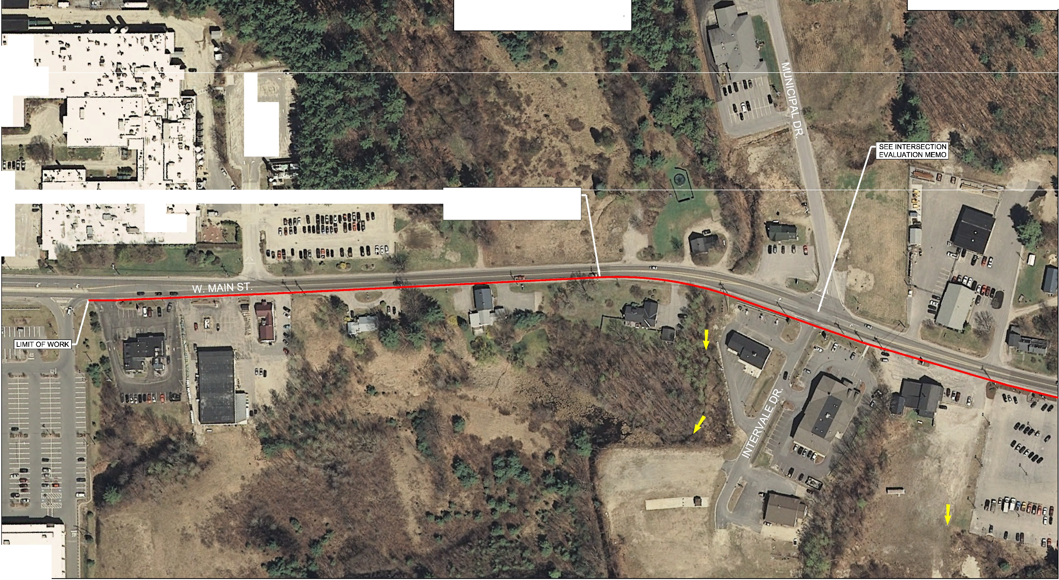

•

ALTERNATIVE NO. 2 I SEGMENT 1 SOUTH SIDE OF WEST MAIN STREET

N

NHDOT PROJECT NO. 41368
DuBOIS & KING PROJECT NO. 324277L 1

SEGMENT 2
MUNICIPAL DRIVE TO WALL STREET

ALTERNATIVE No. 2
···. - ALIGNMENT
SIDEWALK ALTERNATIVE c-=:> EXISTING DRAIN OUTLET

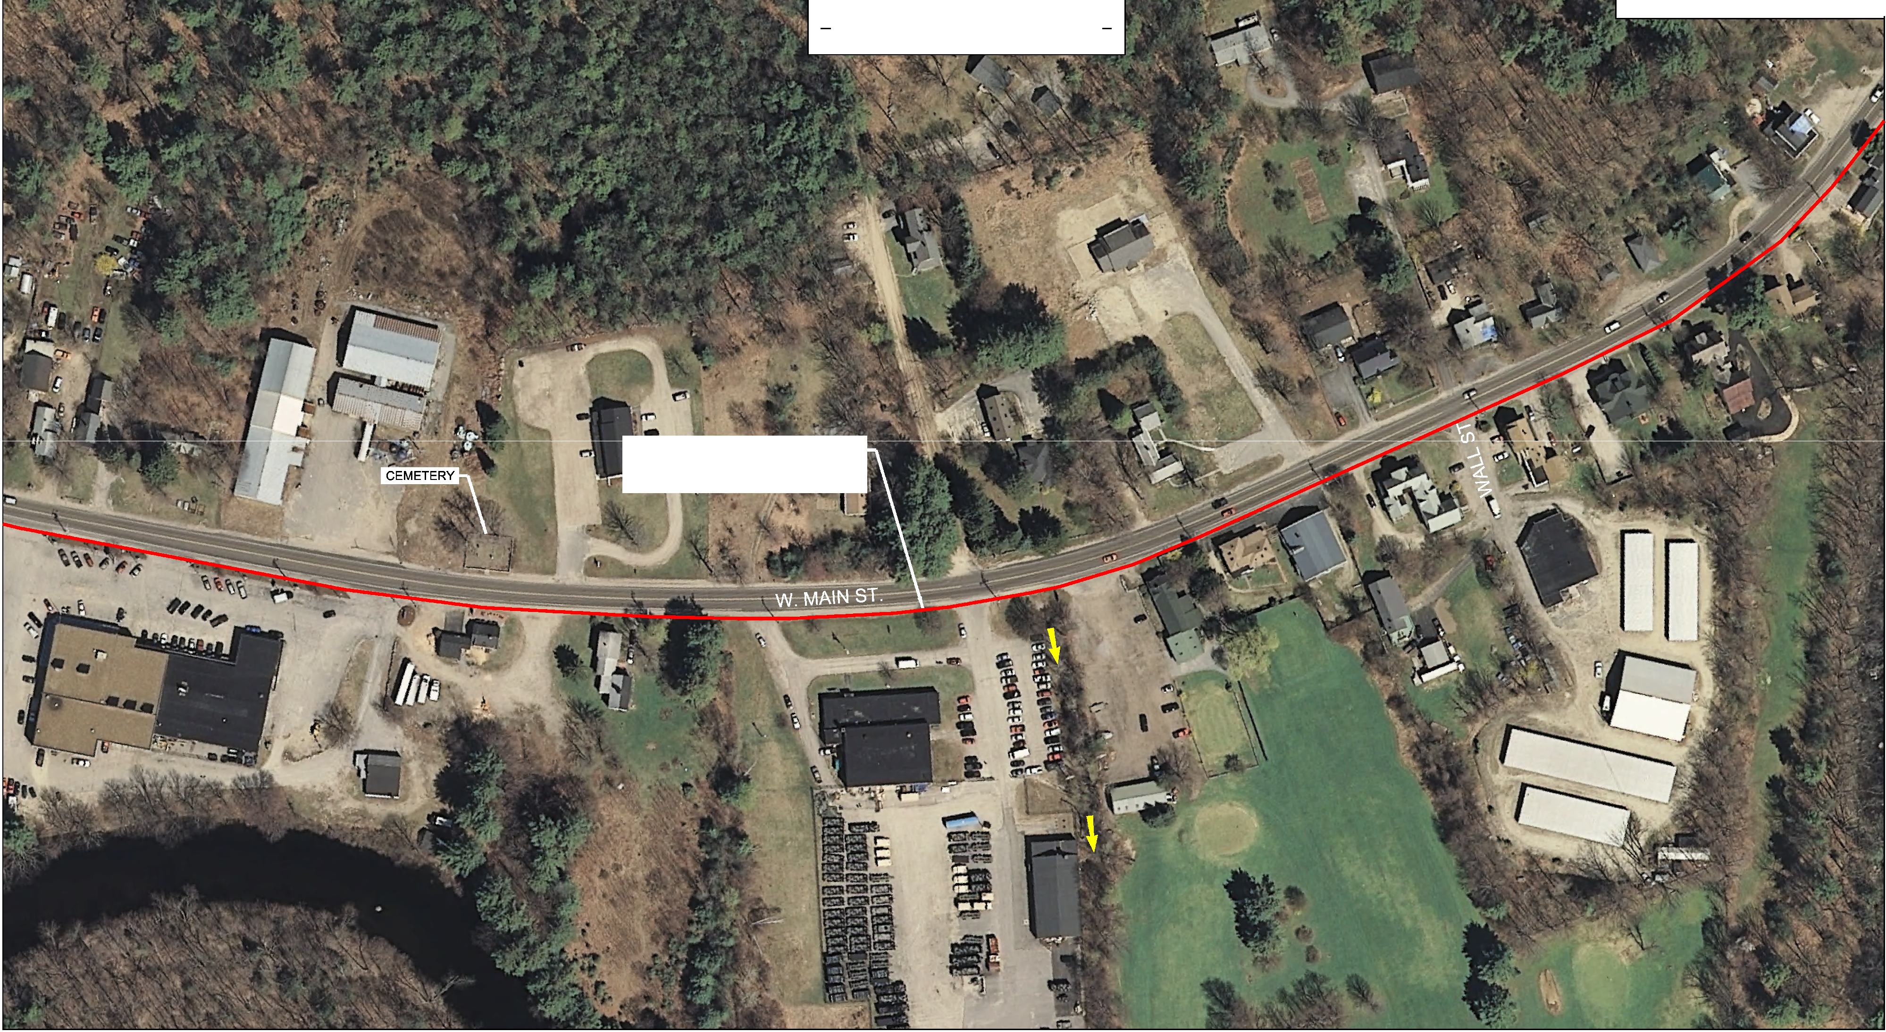

ALTERNATIVE NO. 2 I SEGMENT 2 SOUTH SIDE OF WEST MAIN STREET
N NHDOT PROJECT NO. 41368
DuBOIS & KING PROJECT NO. 324277L 1

SEGMENT 3
WALL STREET TO EAST END
SIDEWALK ALTERNATIVE c-=:> EXISTING DRAIN OUTLET

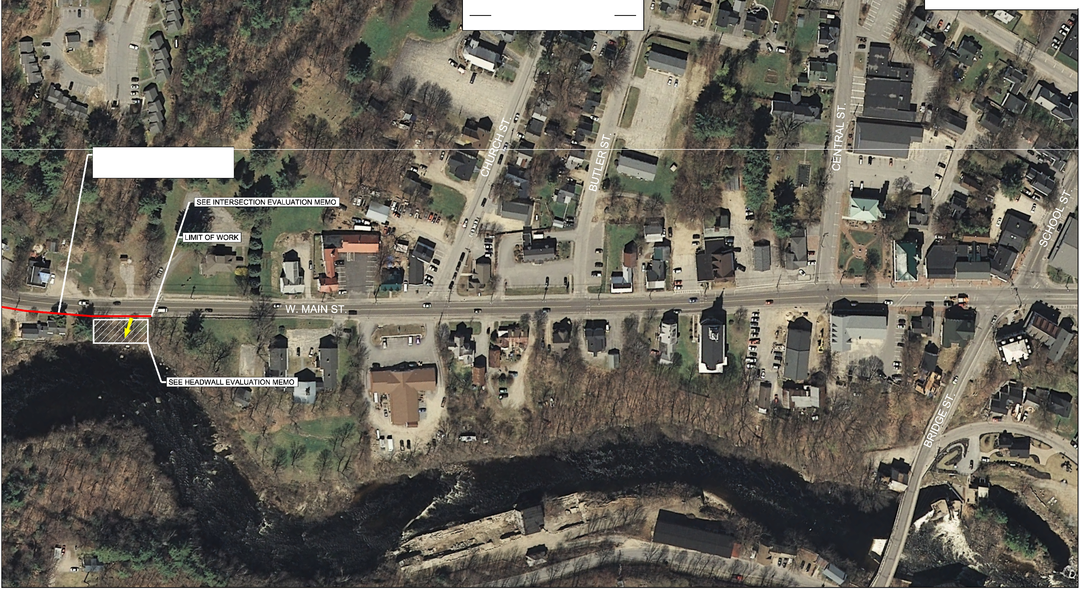

ALTERNATIVE No. 2 ALIGNMENT

ALTERNATIVE NO. 2 I SEGMENT 3 SOUTH SIDE OF WEST MAIN STREET
N

NHDOT PROJECT NO. 41368
DuBOIS & KING PROJECT NO. 324277L 1

•
•
'
- ·. .
- ' %DU'

SEGMENT 1
DUNKIN DONUTS TO MUNICIPAL DRIVE
SIDEWALK ALTERNATIVE c-=:> EXISTING DRAIN OUTLET

l!·il
6
•·•

I
.18
I
'

• ,. • '
- .•

ALTERNATIVE No. 3 ALIGNMENT

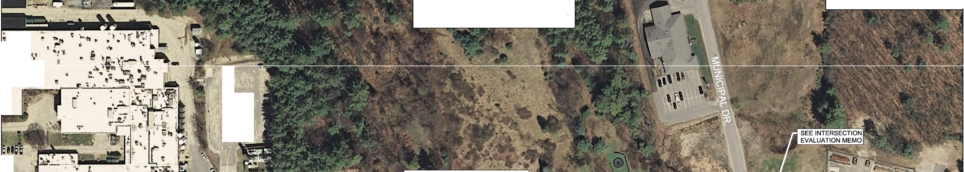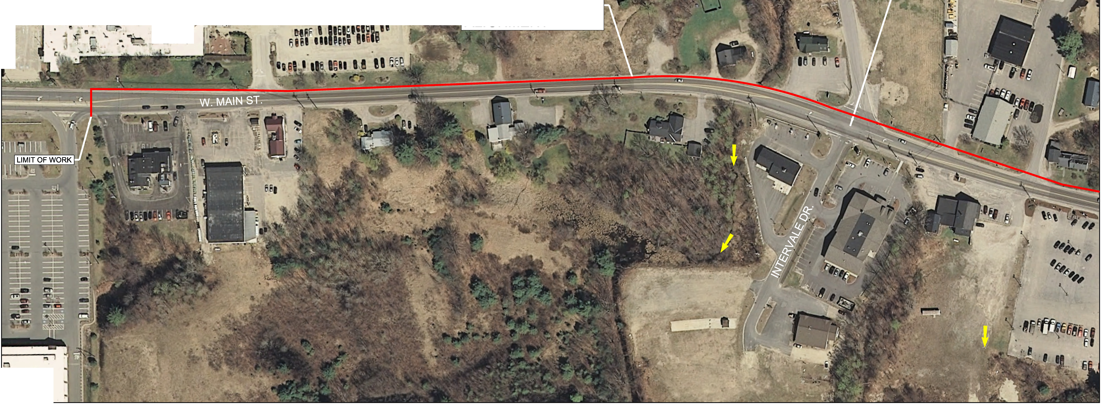

•

ALTERNATIVE NO. 3 I SEGMENT 1 NORTH SIDE OF WEST MAIN STREET

N

NHDOT PROJECT NO. 41368
DuBOIS & KING PROJECT NO. 324277L 1

SEGMENT 2
MUNICIPAL DRIVE TO WALL STREET

ALTERNATIVE No. 3
···. - AL IGNMENT
SIDEWALK ALTERNATIVE c-=:> EXISTING DRAIN OUTLET

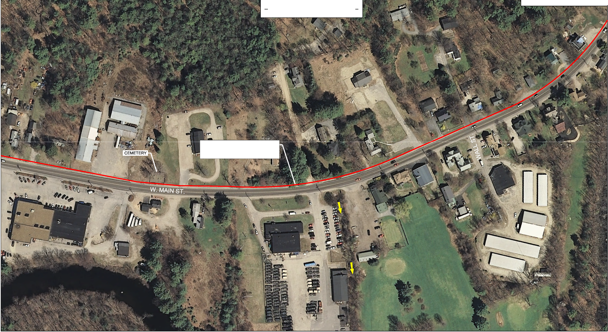

ALTERNATIVE NO. 3 I SEGMENT 2 NORTH SIDE OF WEST MAIN STREET
N NHDOT PROJECT NO. 41368
DuBOIS & KING PROJECT NO. 324277L 1

SEGMENT 3
WALL STREET TO EAST END
SIDEWALK ALTERNATIVE c-=:> EXISTING DRAIN OUTLET

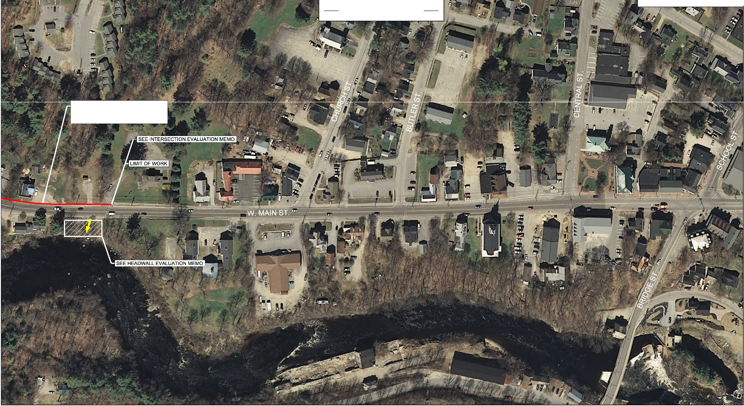

ALTERNATI VE No. 3 ALIGNMENT

ALTERNATIVE NO. 3 I SEGMENT 3 NORTH SIDE OF WEST MAIN STREET
N

NHDOT PROJECT NO. 41368
DuBOIS & KING PROJECT NO. 324277L 1

APPENDIX B

CONCEPT TYPICAL SECTIONS

0  ...J  <t l/l D  []_  D  0::  []_  0:: LL.I I- LL  <t  lz/l  D-  V-l  >  LL.I  0::  0  0 | z  -,_  a-..  Q:  '-'  "w'  0 |  |  |  | AL TERNAT I VE 3 AL TERNAT I VE 2  SIDEWAL K ON NORTH SIDE SIDEWAL K ON SOUTH SIDE  ROADWAY it  5' 1 4'-0" TO ct C M I N. l 1 4'-0" TO ct C M I N. l 5'  SIDEWAL K 1 6'-0 " TO Ii; (PREFERRED) 16'-0" TO Ii; (PREFERRED> SIDEWALK  MAX 3:1 SLOPE -17" 1 ' !TYP .l 1' !TYP .l - - 1 <X "' SCOPE  LOAM & SEED SAWCUT SAWCUT LOAM & SEED  M  16" -  -- 2.0% ' j _,. ,' /,(//Y, {/,(//V, /AWAV  2 . %  0  vIA'V!' IA»>I'JA\'YIA\ ---;----1'1--+t --.  SIDEWALK ,,.,,."""""'""I J \,SI.DE"WA'L""K '"'"'  6" CRUSHED GRAVEL SUBBASE 1 8"X7" VERT ICAL GRAN I TE 6" CRUSHED GRAVEL SUBBASE  NH DOT 304.3 CTYP. l CURB FLUSH SIDEWAL K CURB FLUSH SIDEWALK NHDOT 304.3 (TYP.l  WEST MA I N STR EET TYP I CA L CUR BED B I TUM I NOUS S I DEWA LK  TYP I CAL SECT I ON  ROADWAY it  ROADWAY it ' 1 4 ' -0" TO ct C M I N .l 5' PARK I NG LOT  ; 1 4'-0" TO cl'. !MI N. l 3' 5' 16'-0" TO q; < PREFERRED > SIDEWAL K  SAWCUT SAWCUT  1 ' (TYP.l  'l -2-.-0-%- 1  SEED ..6...".  SLOPE
z
-,_
,"_'
"'
z
0
,_
,"_'
"'
w,_
"'
Q:
w

z:J
"-'  0  N  'Cl)  N  'NN  w,_  0"' |  |  |  |  | ®.V/AWA\V/l.\V LI  SL OPE t 2" B I TUM I NOUS J 2" B I TUM I NOUS
0
'Cl) VAR !ES 1 8"X7" VER T I CAL GRANI TE SIDEWAL K
N 6" CRUSHED GRAVEL SUBBASE CURB FLUSH W/WALK WAY
' NHOOT 304.3 (TYP .) I TYP.l 6" CRUSHED GRAVEL SUBBASE NHDOT 304.3 (TYP.l

w,_ w,_ w,_
"' "' 0"' WEST MA I N STR EET
TYP I CAL UN CURBED B I TUM I N OUS WEST MA I N STR EET
S I DEWA L K DETA I L TYP I CA L DOUBL E -CU R B B I TU M I N OUS
S I DEWA LK DETA I L

I NOT FOR CONSTRUCTION I
 |  |  |  |  |  |  | TOWN OF H I LLSBOROUGH , NEW HAMPSH I RE
 |  |  |  |  |  |  | T YPI CA L SEC TI ON
•
n:.
 |  |  |  |  |  |  | DGN | STATE PROJECT NO. | SHEET NO. | TOTAL SHEETS
 |  |  |  |  |  |  | t yp ica l | 4 1364 | 1 | 1

"-'
2.0%
i 1 6'-0" TO '/; !PREF ERRED! |  | SIDEWALK |  |  | LOAM &
•
I
I
' SAWCUT
f--
1$
2- 0% |  |  |  | / | MAX 3:1
I |  |  | .

N
-----'I\

SIDEWAL K
2 .0% . '
I
1 ' (TYP .)
·-

APPENDIX C

ENGINEER’S OPINION OF PROBABLE CONSTRUCTION COST

Project: Hillsborough West Main Sidewalk (Alt. 2 - Seg. 1)

ENGINEERING ● PLANNING ● MANAGEMENT ● DEVELOPMENT

Calculated By:

Checked By:
BJV Date: 2/19/2019

DMB Date: 2/22/2019

NOTE: In providing opinions of probable construction costs, the Client understands that DuBois & King, Inc. has no control over the cost or availability of labor, equipment or materials, or over market conditions or the Contractor's methods of pricing, and that our Opinion of Probable Construction Costs are made on the basis of our professional judgment and experience. DuBois & King, Inc. makes no warranty, expressed or implied, that the bids or the negotiated costs of the Work will not vary from the Opinion of Probable Construction Cost provided herein.

OPINION OF PROBABLE CONSTRUCTION COST
UNIT NO. | DESCRIPTION | UNIT | QUANTITY | UNIT PRICE | AMOUNT
203.1 | Common Excavation | CY | 250 | $ 15.00 | $ 3,751.00
304.3 | Crushed Gravel (F) | CY | 180 | $ 40.00 | $ 7,200.00
403.11 | Hot Bitumimnous Pavement, Machine Method | TON | 115 | $ 90.00 | $ 10,350.00
403.12 | Hot Bitumimnous Pavement, Hand Method | TON | 9 | $ 180.00 | $ 1,620.00
608.441 | Concrete Sidewalk Tip-downs (Fiber Reinf., 4" Depth) | SY | 110 | $ 60.00 | $ 6,600.00
608.54 | Detectable Warning Device, Cast Iron | SY | 33 | $ 430.00 | $ 14,195.00
609.01 | Straight Granite Curb | LF | 1500 | $ 25.00 | $ 37,500.00
618.7 | Flaggers | HR | 320 | $ 21.00 | $ 6,720.00
619.1 | Maintenance of Traffic | U | 1 | $ 3,000.00 | $ 3,000.00
619.3 | Portable Message Sign | U | 2 | $ 2,500.00 | $ 5,000.00
628.2 | Sawed Bituminous Pavement | LF | 1500 | $ 2.00 | $ 3,000.00
632.0112 | Retroreflective Pavement Marking, 12" Line | LF | 220 | $ 0.75 | $ 165.00
632.912 | Obliterate Pave. Marking Line, Over 12" Wide | LF | 120 | $ 2.00 | $ 240.00
641 | Loam | CY | 100 | $ 30.00 | $ 3,000.00
645.119 | Mulch with Tackifiers | A | 0.17 | $ 1,300.00 | $ 221.00
645.7 | Stormwater Pollution Prevention Plan (SWPPP) | U | 1 | $ 2,000.00 | $ 2,000.00
692 | Mobilization | U | 1 | $ 10,000.00 | $ 10,000.00
699 | Miscellaneous Temporary Erosion Control | U | 1 | $ 2,000.00 | $ 2,000.00
799 | Miscellaneous Headwall Improvements | U | 1 | $ 28,000.00 | $ 28,000.00
999 | Miscellaneous Drainage Improvements | U | 1 | $ 16,000.00 | $ 16,000.00
Sub-Total $ 160,562.00
25% Contingency $ 40,140.50
PROJECT COST ESTIMATE $ 201,000.00

Project: Hillsborough West Main Sidewalk (Alt. 2 - Seg. 2)

ENGINEERING ● PLANNING ● MANAGEMENT ● DEVELOPMENT

Calculated By:

Checked By:
BJV Date: 2/19/2019

DMB Date: 2/22/2019

NOTE: In providing opinions of probable construction costs, the Client understands that DuBois & King, Inc. has no control over the cost or availability of labor, equipment or materials, or over market conditions or the Contractor's methods of pricing, and that our Opinion of Probable Construction Costs are made on the basis of our professional judgment and experience. DuBois & King, Inc. makes no warranty, expressed or implied, that the bids or the negotiated costs of the Work will not vary from the Opinion of Probable Construction Cost provided herein.

OPINION OF PROBABLE CONSTRUCTION COST
UNIT NO. | DESCRIPTION | UNIT | QUANTITY | UNIT PRICE | AMOUNT
203.1 | Common Excavation | CY | 260 | $ 15.00 | $ 3,900.00
304.3 | Crushed Gravel (F) | CY | 140 | $ 40.00 | $ 5,599.00
403.11 | Hot Bitumimnous Pavement, Machine Method | TON | 125 | $ 90.00 | $ 11,250.00
403.12 | Hot Bitumimnous Pavement, Hand Method | TON | 9 | $ 180.00 | $ 1,620.00
608.441 | Concrete Sidewalk Tip-downs (Fiber Reinf., 4" Depth) | SY | 95 | $ 60.00 | $ 5,702.00
608.54 | Detectable Warning Device, Cast Iron | SY | 30 | $ 430.00 | $ 12,886.00
609.01 | Straight Granite Curb | LF | 1500 | $ 25.00 | $ 37,500.00
618.7 | Flaggers | HR | 320 | $ 21.00 | $ 6,720.00
619.1 | Maintenance of Traffic | U | 1 | $ 3,000.00 | $ 3,000.00
619.3 | Portable Message Sign | U | 2 | $ 2,500.00 | $ 5,000.00
628.2 | Sawed Bituminous Pavement | LF | 1500 | $ 2.00 | $ 3,000.00
641 | Loam | CY | 100 | $ 30.00 | $ 2,999.26
645.119 | Mulch with Tackifiers | A | 0.17 | $ 1,300.00 | $ 222.34
645.7 | Stormwater Pollution Prevention Plan (SWPPP) | U | 1 | $ 2,000.00 | $ 2,000.00
692 | Mobilization | U | 1 | $ 10,000.00 | $ 10,000.00
699 | Miscellaneous Temporary Erosion Control | U | 1 | $ 2,000.00 | $ 2,000.00
799 | Miscellaneous Headwall Improvements | U | 1 | $ 28,000.00 | $ 28,000.00
999 | Miscellaneous Drainage Improvements | U | 1 | $ 17,000.00 | $ 17,000.00
Sub-Total $ 158,398.60
25% Contingency $ 39,599.65
PROJECT COST ESTIMATE $ 198,000.00

Project: Hillsborough West Main Sidewalk (Alt. 2 - Seg. 3)

ENGINEERING ● PLANNING ● MANAGEMENT ● DEVELOPMENT

Calculated By:

Checked By:
BJV Date: 2/19/2019

DMB Date: 2/22/2019

NOTE: In providing opinions of probable construction costs, the Client understands that DuBois & King, Inc. has no control over the cost or availability of labor, equipment or materials, or over market conditions or the Contractor's methods of pricing, and that our Opinion of Probable Construction Costs are made on the basis of our professional judgment and experience. DuBois & King, Inc. makes no warranty, expressed or implied, that the bids or the negotiated costs of the Work will not vary from the Opinion of Probable Construction Cost provided herein.

OPINION OF PROBABLE CONSTRUCTION COST
UNIT NO. | DESCRIPTION | UNIT | QUANTITY | UNIT PRICE | AMOUNT
203.1 | Common Excavation | CY | 116 | $ 15.00 | $ 1,740.00
304.3 | Crushed Gravel (F) | CY | 81 | $ 40.00 | $ 3,240.00
403.11 | Hot Bitumimnous Pavement, Machine Method | TON | 55 | $ 90.00 | $ 4,950.00
403.12 | Hot Bitumimnous Pavement, Hand Method | TON | 4 | $ 180.00 | $ 720.00
608.441 | Concrete Sidewalk Tip-downs (Fiber Reinf., 4" Depth) | SY | 50 | $ 60.00 | $ 2,998.00
608.54 | Detectable Warning Device, Cast Iron | SY | 16 | $ 430.00 | $ 6,880.00
609.01 | Straight Granite Curb | LF | 650 | $ 25.00 | $ 16,250.00
615.0301 | Traffic Sign, Type C | SF | 8 | $ 35.00 | $ 280.00
618.7 | Flaggers | HR | 320 | $ 21.00 | $ 6,720.00
619.1 | Maintenance of Traffic | U | 1 | $ 3,000.00 | $ 3,000.00
619.3 | Portable Message Sign | U | 2 | $ 2,500.00 | $ 5,000.00
628.2 | Sawed Bituminous Pavement | LF | 650 | $ 2.00 | $ 1,300.00
632.0112 | Retroreflective Pavement Marking, 12" Line | LF | 150 | $ 0.75 | $ 113.00
632.912 | Obliterate Pave. Marking Line, Over 12" Wide | LF | 110 | $ 2.00 | $ 220.00
641 | Loam | CY | 46 | $ 30.00 | $ 1,380.00
645.119 | Mulch with Tackifiers | A | 0.1 | $ 1,300.00 | $ 130.00
645.7 | Stormwater Pollution Prevention Plan (SWPPP) | U | 1 | $ 2,000.00 | $ 2,000.00
692 | Mobilization | U | 1 | $ 10,000.00 | $ 10,000.00
699 | Miscellaneous Temporary Erosion Control | U | 1 | $ 2,000.00 | $ 2,000.00
799 | Miscellaneous Headwall Improvements | U | 1 | $ 28,000.00 | $ 28,000.00
999 | Miscellaneous Drainage Improvements | U | 1 | $ 10,000.00 | $ 10,000.00
Sub-Total $ 106,921.00
25% Contingency $ 26,730.25
PROJECT COST ESTIMATE $ 134,000.00

Project: Hillsborough West Main Sidewalk (Alt. 3 - Seg. 1)

ENGINEERING ● PLANNING ● MANAGEMENT ● DEVELOPMENT

Calculated By:

Checked By:
BJV Date: 2/19/2019

DMB Date: 2/22/2019

NOTE: In providing opinions of probable construction costs, the Client understands that DuBois & King, Inc. has no control over the cost or availability of labor, equipment or materials, or over market conditions or the Contractor's methods of pricing, and that our Opinion of Probable Construction Costs are made on the basis of our professional judgment and experience. DuBois & King, Inc. makes no warranty, expressed or implied, that the bids or the negotiated costs of the Work will not vary from the Opinion of Probable Construction Cost provided herein.

OPINION OF PROBABLE CONSTRUCTION COST
UNIT NO. | DESCRIPTION | UNIT | QUANTITY | UNIT PRICE | AMOUNT
203.1 | Common Excavation | CY | 211 | $ 15.00 | $ 3,165.00
304.3 | Crushed Gravel (F) | CY | 150 | $ 40.00 | $ 6,000.00
403.11 | Hot Bitumimnous Pavement, Machine Method | TON | 105 | $ 90.00 | $ 9,450.00
403.12 | Hot Bitumimnous Pavement, Hand Method | TON | 7 | $ 180.00 | $ 1,260.00
608.441 | Concrete Sidewalk Tip-downs (Fiber Reinf., 4" Depth) | SY | 61 | $ 60.00 | $ 3,660.00
608.54 | Detectable Warning Device, Cast Iron | SY | 20 | $ 430.00 | $ 8,600.00
609.01 | Straight Granite Curb | LF | 1200 | $ 25.00 | $ 30,000.00
615.0301 | Traffic Sign, Type C | SF | 8 | $ 35.00 | $ 280.00
618.7 | Flaggers | HR | 320 | $ 21.00 | $ 6,720.00
619.1 | Maintenance of Traffic | U | 1 | $ 3,000.00 | $ 3,000.00
619.3 | Portable Message Sign | U | 2 | $ 2,500.00 | $ 5,000.00
628.2 | Sawed Bituminous Pavement | LF | 1200 | $ 2.00 | $ 2,400.00
632.0112 | Retroreflective Pavement Marking, 12" Line | LF | 550 | $ 0.75 | $ 413.00
641 | Loam | CY | 81 | $ 30.00 | $ 2,430.00
645.119 | Mulch with Tackifiers | A | 0.2 | $ 1,300.00 | $ 260.00
645.7 | Stormwater Pollution Prevention Plan (SWPPP) | U | 1 | $ 2,000.00 | $ 2,000.00
692 | Mobilization | U | 1 | $ 10,000.00 | $ 10,000.00
699 | Miscellaneous Temporary Erosion Control | U | 1 | $ 2,000.00 | $ 2,000.00
799 | Miscellaneous Headwall Improvements | U | 1 | $ 28,000.00 | $ 28,000.00
999 | Miscellaneous Drainage Improvements | U | 1 | $ 16,000.00 | $ 16,000.00
Sub-Total $ 140,638.00
25% Contingency $ 35,159.50
PROJECT COST ESTIMATE $ 176,000.00

Project: Hillsborough West Main Sidewalk (Alt. 3 - Seg. 2)

ENGINEERING ● PLANNING ● MANAGEMENT ● DEVELOPMENT

Calculated By:

Checked By:
BJV Date: 2/19/2019

DMB Date: 2/22/2019

NOTE: In providing opinions of probable construction costs, the Client understands that DuBois & King, Inc. has no control over the cost or availability of labor, equipment or materials, or over market conditions or the Contractor's methods of pricing, and that our Opinion of Probable Construction Costs are made on the basis of our professional judgment and experience. DuBois & King, Inc. makes no warranty, expressed or implied, that the bids or the negotiated costs of the Work will not vary from the Opinion of Probable Construction Cost provided herein.

OPINION OF PROBABLE CONSTRUCTION COST
UNIT NO. | DESCRIPTION | UNIT | QUANTITY | UNIT PRICE | AMOUNT
203.1 | Common Excavation | CY | 300 | $ 15.00 | $ 4,500.00
304.3 | Crushed Gravel (F) | CY | 210 | $ 40.00 | $ 8,401.00
403.11 | Hot Bitumimnous Pavement, Machine Method | TON | 150 | $ 90.00 | $ 13,500.00
403.12 | Hot Bitumimnous Pavement, Hand Method | TON | 10 | $ 180.00 | $ 1,800.00
608.441 | Concrete Sidewalk Tip-downs (Fiber Reinf., 4" Depth) | SY | 80 | $ 60.00 | $ 4,799.00
608.54 | Detectable Warning Device, Cast Iron | SY | 26 | $ 430.00 | $ 11,180.00
609.01 | Straight Granite Curb | LF | 1700 | $ 25.00 | $ 42,500.00
618.7 | Flaggers | HR | 320 | $ 21.00 | $ 6,720.00
619.1 | Maintenance of Traffic | U | 1 | $ 3,000.00 | $ 3,000.00
619.3 | Portable Message Sign | U | 2 | $ 2,500.00 | $ 5,000.00
628.2 | Sawed Bituminous Pavement | LF | 1700 | $ 2.00 | $ 3,400.00
641 | Loam | CY | 110 | $ 30.00 | $ 3,300.00
645.119 | Mulch with Tackifiers | A | 0.2 | $ 1,300.00 | $ 260.00
645.7 | Stormwater Pollution Prevention Plan (SWPPP) | U | 1 | $ 2,000.00 | $ 2,000.00
692 | Mobilization | U | 1 | $ 10,000.00 | $ 10,000.00
699 | Miscellaneous Temporary Erosion Control | U | 1 | $ 2,000.00 | $ 2,000.00
799 | Miscellaneous Headwall Improvements | U | 1 | $ 28,000.00 | $ 28,000.00
999 | Miscellaneous Drainage Impvrovements | U | 1 | $ 17,000.00 | $ 17,000.00
Sub-Total $ 167,360.00
25% Contingency $ 41,840.00
PROJECT COST ESTIMATE $ 210,000.00

Project: Hillsborough West Main Sidewalk (Alt. 3 - Seg. 3)

ENGINEERING ● PLANNING ● MANAGEMENT ● DEVELOPMENT

Calculated By:

Checked By:
BJV Date: 2/19/2019

DMB Date: 2/22/2019

NOTE: In providing opinions of probable construction costs, the Client understands that DuBois & King, Inc. has no control over the cost or availability of labor, equipment or materials, or over market conditions or the Contractor's methods of pricing, and that our Opinion of Probable Construction Costs are made on the basis of our professional judgment and experience. DuBois & King, Inc. makes no warranty, expressed or implied, that the bids or the negotiated costs of the Work will not vary from the Opinion of Probable Construction Cost provided herein.

OPINION OF PROBABLE CONSTRUCTION COST
UNIT NO. | DESCRIPTION | UNIT | QUANTITY | UNIT PRICE | AMOUNT
203.1 | Common Excavation | CY | 112 | $ 15.00 | $ 1,680.00
304.3 | Crushed Gravel (F) | CY | 71 | $ 40.00 | $ 2,840.00
403.11 | Hot Bitumimnous Pavement, Machine Method | TON | 56 | $ 90.00 | $ 5,040.00
403.12 | Hot Bitumimnous Pavement, Hand Method | TON | 14 | $ 180.00 | $ 2,520.00
608.441 | Concrete Sidewalk Tip-downs (Fiber Reinf., 4" Depth) | SY | 40 | $ 60.00 | $ 2,400.00
608.54 | Detectable Warning Device, Cast Iron | SY | 13 | $ 430.00 | $ 5,590.00
609.01 | Straight Granite Curb | LF | 580 | $ 25.00 | $ 14,500.00
615.0301 | Traffic Sign, Type C | SF | 8 | $ 35.00 | $ 280.00
618.7 | Flaggers | HR | 320 | $ 21.00 | $ 6,720.00
619.1 | Maintenance of Traffic | U | 1 | $ 3,000.00 | $ 3,000.00
619.3 | Portable Message Sign | U | 2 | $ 2,500.00 | $ 5,000.00
628.2 | Sawed Bituminous Pavement | LF | 580 | $ 2.00 | $ 1,160.00
632.0112 | Retroreflective Pavement Marking, 12" Line | LF | 150 | $ 0.75 | $ 113.00
632.912 | Obliterate Pave. Marking Line, Over 12" Wide | LF | 110 | $ 2.00 | $ 220.00
641 | Loam | CY | 40 | $ 30.00 | $ 1,200.00
645.119 | Mulch with Tackifiers | A | 0.1 | $ 1,300.00 | $ 130.00
645.7 | Stormwater Pollution Prevention Plan (SWPPP) | U | 1 | $ 2,000.00 | $ 2,000.00
692 | Mobilization | U | 1 | $ 10,000.00 | $ 10,000.00
699 | Miscellaneous Temporary Erosion Control | U | 1 | $ 2,000.00 | $ 2,000.00
799 | Miscellaneous Headwall Improvements | U | 1 | $ 28,000.00 | $ 28,000.00
999 | Drainage Improvements | U | 1 | $ 10,000.00 | $ 10,000.00
Sub-Total $ 102,713.00
25% Contingency $ 25,678.25
PROJECT COST ESTIMATE $ 129,000.00

APPENDIX D

MEMORANDUMS

Darren M. Benoit, PE

18 Constitution Drive, Suite 8
Bedford, NH 03110
Tele: (603) 637-1043
Fax: (866) 783-7101

ENGINEERING • PLANNING • MANAGEMENT • DEVELOPMENT
Senior Transportation Engineer

MEMORANDUM

TO: Scott Bourcier, P.E., Project Manager

RE: Hillsborough TAP – NHDOT Project No. 41368 West Main Street (NH 149) Intersection Evaluations
(1) Municipal Drive/ Intervale Drive, (2) Ex. Mid-Block Crosswalk (near 77 W. Main Street)

DATE: January 21, 2019

We have reviewed the above referenced intersections to evaluate pedestrian improvements with respect to West Main Street. The following paragraphs describe the existing conditions, geometric considerations, and potential road work to improve the safety for pedestrians in this area of Hillsborough.

EXISTING CONDITIONS

Municipal Drive/Intervale Drive intersection with West Main Street (NH 149)
Municipal Drive and Intervale Drive, are local roads, oriented in a north-south direction and intersects West Main Street, a state highway oriented in a west-east direction. The side roads meet West Main Street perpendicularly. The Municipal Drive pavement measures 40’ in width in the area of the intersection, returning to a typical 22’ in width away from the intersection. Left turn and right turn lanes out of Municipal Drive are delineated with a solid white line with arrow and ‘ONLY’ symbols within the lanes. The opposing traffic lanes are delineated with a solid double yellow line. Intervale Drive measures 22’ in width typically, without any delineation of the road surface. Both side roads are stop-controlled with a solid white stop bar. Intervale Drive has a striped crosswalk across the road adjacent the stop bar, but the paint has completed worn away within the travel surface.

West Main Street at this location has left turn lanes in both eastbound and westbound directions in addition to the through lanes with a solid white line and arrow symbol for delineation. Lanes are general 10’ wide with 1’ shoulders. Through this intersection there is a sidewalk on the south side of West Main Street separated from the road by a granite curb. Sidewalk ramps and detectable warning devices are present, but do not meet current ADA standards. There is currently no crosswalk that crosses West Main Street at this intersection.

Based upon visitation, the NH 149 traffic is substantial compared to side road traffic with significant side road traffic only occurring during peak hours. The intersection is located in an area of Hillsborough that is predominantly commercial. The posted speed limit on West Main Street is 30mph. Municipal Drive is posted at 25mph. Intervale Drive is not posted, but is also 25mph.

Existing Crosswalk (near 77 West Main Street)
West Main Street in this location is oriented in a northeast/southwest direction. The crosswalk crosses West Main Street at approximately a 30-degree skew from perpendicular and intersects in a northwest- southeast direction. The crosswalk connects two existing pedestrian facilities. The bituminous sidewalk on the northwest end is in good condition and the bituminous sidewalk on the southeast end in poor condition.

This crosswalk is mid-block with no side roads within the vicinity. There is a commercial driveway on the northwest side of the crosswalk, but traffic from the drive is minimal. West Main Street in this location consists of two 12’ wide lanes and 1’ wide shoulders. Directional traffic is separated by double solid yellow

Hillsborough – West Main Street (NH 149) Intersection Evaluation January 21, 2019
Page 2 of 2

line and lanes are delineated from the shoulders with solid white lines.

The sight distance approaching the crosswalk from both directions is sufficient for the 30mph speed limit. Striping of the crosswalk is sufficient, but there are no signs designating the pedestrian crossing within the area of the crosswalk. This is a striped crosswalk with no signals and no accommodations for ADA compliance.

GEOMETRIC CONSIDERATIONS

Municipal Drive/Intervale Drive intersection with West Main Street (NH 149)
Sight distance along the existing streets is adequate in all directions for all turning movements.

The existing configuration of the intersections performs adequately, but the Municipal Drive leg should be analyzed in the future when survey and turning movements are available. The existing pavement layout appears to be inefficient with more pavement than is necessary. The split left and right turns appear to have limited utility as only a few cars queued up in either lane would block entrance to the second lane.

In the current configuration, a crosswalk could be added by striping across West Main Street and a portion on Municipal Lane. After the intersection has been optimized a more effective crosswalk could be added on the north side of the intersection and provide a safer connection to Municipal Drive.

Existing Crosswalk (near 77 West Main Street)
The skew of this crossing is to take advantage of existing pavement in order to connect the two facilities with only the addition of striping.

Sight distance along West Main Street appears adequate in all directions for the crosswalk considering the speed limit, but vehicles traveling south are leaving a more urbanized area and traveling down a steep road grade, which both typically encourage speeds exceeding the speed limit.

POTENTIAL IMPROVEMENTS

Municipal Drive/Intervale Drive intersection with West Main Street (NH 149)
Upon completion of field survey and acquisition of turning movements, a review of the existing pavement configuration for Municipal Drive should be conducted. This will also require coordination with the Town of Hillsborough. The existing three lane configuration of the road appears to be inefficient and may actually be less safe with mixed vehicle types. Reduction of pavement would also allow for an improved layout for a crosswalk across West Main Street. As part of the preliminary plans crosswalk layout, Municipal Drive should be evaluated within 200 feet of the intersection in order to provide a reasonable approach to the intersection for pedestrians.

Existing sidewalk ramps at this intersection should be upgraded to comply with the latest ADA standards. In their current configuration they do not meet that standard. Municipal Drive provides a pedestrian connection to the High School that should be evaluated for a crossing at West Main Street if the sidewalk along West Main Street is improved.

Existing Crosswalk (near 77 West Main Street)
Ideally, this crossing would be improved by moving the location to the north approximately 20 feet along West Main Street such that the crossing would be independent from the existing commercial drive and made perpendicular to West Main Street. Added to the crossing would be the applicable ADA compliant ramps and detectable warning products.

As a minimum, signage should be added to the existing location to alert traffic in both directions that a crosswalk is present. Additional measures could include the installation of a Speed Limit Sign 200 feet north of the crosswalk to clarify driving expectations when leaving the urbanized area.

End of Memorandum

James Hall, PE

18 Constitution Drive, Suite 8
Bedford, NH 03110
Tele: (603) 637-1043
Fax: (866) 783-7101

ENGINEERING • PLANNING • MANAGEMENT • DEVELOPMENT
Bridge Project Manager

MEMORANDUM

TO: Scott Bourcier, P.E., Project Manager

RE: Hillsborough TAP – NHDOT Project No. 41368 West Main Street Headwall Evaluation

DATE: February 21, 2019

We have evaluated repair/rehabilitation alternatives for the above referenced headwall. The following paragraphs describe the existing conditions, alternatives, and recommendations.

EXISTING CONDITIONS
The referenced headwall is located near 84 West Main Street, adjacent to the Eastbound travel lane, in Hillsborough, NH. Based on our site visit, the headwall material consists of stone masonry with a guardrail embedded on top, and is approximately 8’ high x 15’ long. Portions of the headwall, mostly along the top, appear to have receded into the adjacent brook. Therefore, repair/rehabilitation is recommended to mitigate any further deterioration.

We observed no evidence to indicate deterioration of the existing 36-inch reinforced concrete pipe (RCP) cross-culvert.

As part of this evaluation, we performed a brief hydrologic and hydraulic (H&H) evaluation of the existing cross-culvert. Based on the United States Geological Survey (USGS) StreamStats data, the watershed area that conveys stormwater runoff to this cross culvert is approximately 0.14 square-miles in area; please see attached. The associated runoff flow for this watershed during a 50 and 100-year, 24-hour peak storm events, are approximately 38.1 and 48 cubic-feet/second (cfs); respectively. Assuming the existing cross- culvert is approximately 130 feet long (based on Google Earth) and consist of a half percent (0.5%) slope toward Contoocook River, the hydraulic capacity of the culvert is 60.9 cfs. The brief H&H indicates there are no flooding issues associated with this culvert.

ALTERNATIVES
Alternative #1: Cast-In-Place Concrete Gravity Wall
A reinforced cast-in-place concrete gravity would be placed directly in front of the headwall. A gravity wall would further support the stone masonry portion of the headwall with minimal construction disturbances. No excavation of road or pavement replacement would be required. Estimated cost $28,000.

Alternative #2: Excavate and Replace with New
The existing stone masonry headwall would be removed and replaced with a new concrete headwall. Excavation of the roadway and replacement of pavement within the vicinity of the headwall would be required. Estimated cost $34,000.

Alternative #3: Reconstruct Stone Masonry Headwall
The existing stone masonry headwall would be removed and reconstructed with new mortar. Excavation of the roadway and replacement of pavement within the vicinity of the headwall would be required. Estimated cost $26,000.

RECOMMENDATION
It is recommended to construct a Cast-In-Place Concrete Gravity Wall in front of the existing stone masonry headwall (Alternative #1). This alternative would be cost effective while having low construction impacts.

End of Memorandum

West Main Street Culvert, StreamStats Report, Hillsborough, NH
Region ID: NH
Workspace ID: NH20190212152223170000
Clicked Point {Latitude, Longitude): 43.11115, -71.89940
Time: 2019-02-12 10:21:37 -0500
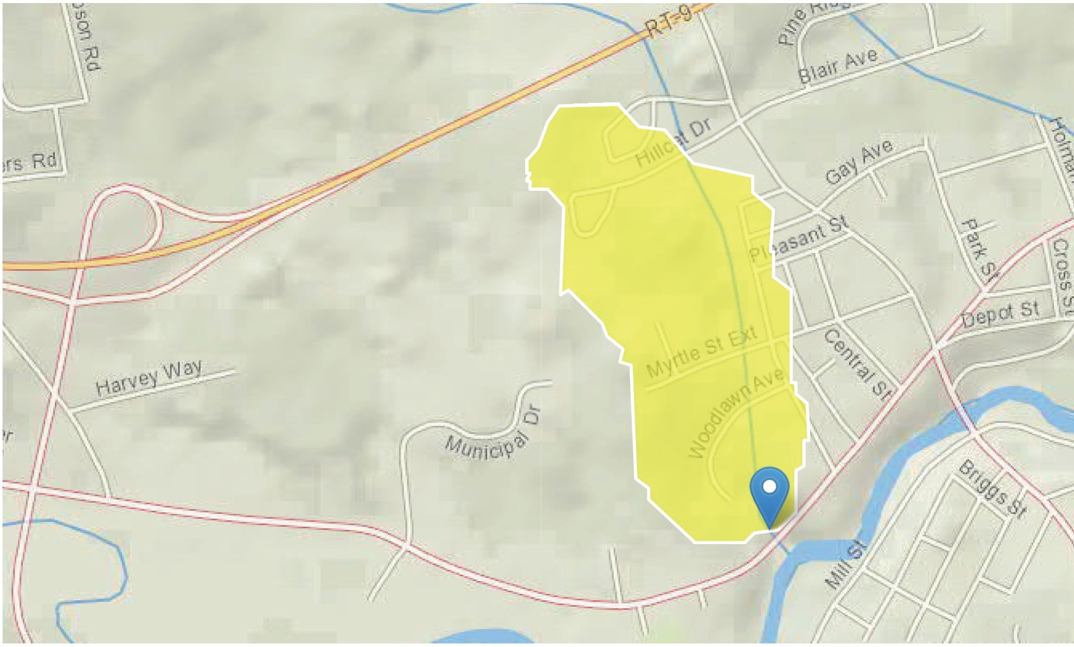

Basin Characteristics

Parameter
Code Parameter Description

DRNAREA Area that drains to a point on a stream

APRAVPRE Mean April Precipitation WETLAND Percentage of Wetlands
CSL 10_85 Change in elevation divided by length between points 10 and 85 percent of distance along main channel to basin divide - main channel method not known

Value Unit

0.14 square miles
3.854 inches

0 percent

116 feet per mi

Peak-Flow Statistics Parameters!Peak Row Statewide s1R200B 5206]

Parameter Code | Parameter Name | Value | Units | Min Limit | Max Limit
DRNAREA | Drainage Area | 0.14 | square miles | 0.7 | 1290
APRAVPRE | Mean April Precipitation | 3.854 | inches | 2.79 | 6.23
WETLAND | Percent Wetlands | 0 | percent | 0 | 21.8
CSL10_85 | Stream Slope 1O and 85 | 116 | feet per mi | 5.43 | 543
 | Method

Peak-Flow Statistics Disclaimers!Peak Flow SlstelvideS1R200B 52061

One or more of the parameters is outside the suggested range. Estimates were extrapolated with unknown errors

Peak-Flow Statistics Flow Report(Peak Flewstatewide s1R'looe 5206]  Statistic | Value | Unit
2 Year Peak Flood | 7.93 | ftA3/S
5 Year Peak Flood | 14.6 | ftA3/S
10 Year Peak Flood | 20.8 | ftA3/S
25 Year Peak Flood | 30 | ftA3/S
50 Year Peak Flood | 38.1 | ftA3/S
100 Year Peak Flood | 48 | ftA3/S
500 Year Peak Flood | 74.9 | ftA3/S
Peak-Flow Statistics Citations

Olson, S.A.,2009, Estimation of flood discharges at selected recurrence intervals for streams In New Hampshire: U.S.Geologlcal Survey Scientific Investigations Report 2008-5206, 57 p. (http://pubs. usgs.gov/sir/2008/5206/)

USGS Data Disclaimer: Unless otherwise stated, all data, metadata and related materials are considered to satisfy the quality standards relative to the purpose for which the data were collected. Although these data and associated metadata have been reviewed for accuracy and completeness and approved for release by the U.S. Geological Survey
{USGS), no warranty expressed orimplied is made regarding the display or utility of the data for other purposes, nor on all computer systems,nor shall the act of distribution constitute any such warranty.

USGS Software Disclaimer: This software has been approved for release by the U.S. Geological Survey {USGS). Although the software has been subjected to rigorous review, the USGS reserves the right to update the software as needed pursuant to further analysis and review. No warranty, expressed or implied, is made by the USGS or the U.S.

Government as to the functionality of the software and related material nor shall the fact of release constitute any such warranty. Furthermore, the software is released on condition that neither the USGS nor the U.S. Government shall be held liable for any damages resultingfrom its authorized or unauthorized use.

USGS Product Names Disclaimer: Any use of trade, firm, or product names is for descriptive purposes only and does not imply endorsement by the U.S. Government.

Application Version: 4.3.0

Culvert Analysis Spreadsheet Ver 5/2012

Client: | Hillsborough, NH | County: | Date: | 2/20/2019
Design By: | JCH | Checked By: | Date:
Comments: | 36" RCP Culvert - 84 West Main Street

Inputs:
Headwater (Upstream Water Surface) Elevation:
Culvert Inlet Invert Elevation:
Culvert Diameter: Length of Culvert:
Culvert Outlet Invert Elevation: Tailwater (Downstream) Elevation:

Feet Feet
Concrete
Headwall - Square Edge
106.65
100.65
36.00
130.00
100.00
104.00

Inches Select Culvert Material:
Feet Select Culvert Inlet Type: Feet
Feet

Outputs:

CAPACITY = 60.9 cfs OUTLET CONTROLS - Full Flow

Manning's n value: 0.012 Concrete
Entrance Coefficient, Ke: 0.5 Headwall - Square Edge

Project: Hillsborough West Main Sidewalk

ENGINEERING ● PLANNING ● MANAGEMENT ● DEVELOPMENT

Calculated By: Checked By:
ZJZ Date: 2/20/2019

JCH Date: 2/21/2019

Printed: 2/26/2019

NOTE: In providing opinions of probable construction costs, the Client understands that DuBois & King, Inc. has no control over the cost or availability of labor, equipment or materials, or over market conditions or the Contractor's methods of pricing, and that our Opinion of Probable Construction Costs are made on the basis of our professional judgment and experience. DuBois & King, Inc. makes no warranty, expressed or implied, that the bids or the negotiated costs of the Work will not vary from the Opinion of Probable Construction Cost provided herein.

ENGINEER'S OPINION OF CONSTRUCTION COST ALTERNATIVE #1: CIP CONCRETE GRAVITY WALL

UNIT NO. | DESCRIPTION | UNIT | QUANTITY | UNIT PRICE |  | AMOUNT
520.01 | Concrete Class AA | CY | 20 | $ | 1,000.00 | $ | 20,000.00
544.2 | Reinforcing Steel | LB | 5,000 | $ | 1.50 | $ | 7,500.00

Sub-Total $ 0% Contigency $ Sub-Total $
27,500.00
-
27,500.00

ESTIMATE $ 28,000.00

\\BNH-FIL-W12-01\Projects\3\324277 Hillsborough West Main Sidewalk\02 Study\02 Civil\Headwall Estimates.xlsx 1 of 1

Project: Hillsborough West Main Sidewalk

ENGINEERING ● PLANNING ● MANAGEMENT ● DEVELOPMENT

Calculated By: Checked By:
ZJZ Date: 2/20/2019

JCH Date: 2/21/2019

Printed: 2/26/2019

NOTE: In providing opinions of probable construction costs, the Client understands that DuBois & King, Inc. has no control over the cost or availability of labor, equipment or materials, or over market conditions or the Contractor's methods of pricing, and that our Opinion of Probable Construction Costs are made on the basis of our professional judgment and experience. DuBois & King, Inc. makes no warranty, expressed or implied, that the bids or the negotiated costs of the Work will not vary from the Opinion of Probable Construction Cost provided herein.

ENGINEER'S OPINION OF CONSTRUCTION COST ALTERNATIVE #2: EXCAVATE AND REPLACE WITH NEW

UNIT NO. | DESCRIPTION | UNIT | QUANTITY | UNIT PRICE |  | AMOUNT
202 | Removal of Headwall | U | 1 | $ | 5,000.00 | $ | 5,000.00
203.1 | Common Excavation | CY | 50 | $ | 20.00 | $ | 1,000.00
403.11 | Hot Bitum. Pave, Machine Method, 19mm | TON | 1.0 | $ | 100.00 | $ | 100.00
900.1 | Precast Concrete Headwall | U | 1 | $ | 27,500.00 | $ | 27,500.00

Sub-Total $ 0% Contigency $ Sub-Total $
33,600.00
-
33,600.00

ESTIMATE $ 34,000.00

\\BNH-FIL-W12-01\Projects\3\324277 Hillsborough West Main Sidewalk\02 Study\02 Civil\Headwall Estimates.xlsx 1 of 1

Project: Hillsborough West Main Sidewalk

ENGINEERING ● PLANNING ● MANAGEMENT ● DEVELOPMENT

Calculated By: Checked By:
ZJZ Date: 2/20/2019

JCH Date: 2/21/2019

Printed: 2/26/2019

NOTE: In providing opinions of probable construction costs, the Client understands that DuBois & King, Inc. has no control over the cost or availability of labor, equipment or materials, or over market conditions or the Contractor's methods of pricing, and that our Opinion of Probable Construction Costs are made on the basis of our professional judgment and experience. DuBois & King, Inc. makes no warranty, expressed or implied, that the bids or the negotiated costs of the Work will not vary from the Opinion of Probable Construction Cost provided herein.

ENGINEER'S OPINION OF CONSTRUCTION COST ALTERNATIVE #3: RECONSTRUCT STONE MASONRY HEADWALL

UNIT NO. | DESCRIPTION | UNIT | QUANTITY | UNIT PRICE |  | AMOUNT
203.1 | Common Excavation | CY | 50 | $ | 20.00 | $ | 1,000.00
403.11 | Hot Bitum. Pave, Machine Method, 19mm | TON | 1.0 | $ | 100.00 | $ | 100.00
900.2 | Reconstruct Stone Masonry Headwall | U | 1 | $ | 24,000.00 | $ | 24,000.00

Sub-Total $ 0% Contigency $ Sub-Total $
25,100.00
-
25,100.00

ESTIMATE $ 26,000.00

\\BNH-FIL-W12-01\Projects\3\324277 Hillsborough West Main Sidewalk\02 Study\02 Civil\Headwall Estimates.xlsx 1 of 1

Ross L. Tsantoulis, P.E.

18 Constitution Drive, Suite 8
Bedford, NH 03110
Tele: (603) 637-1043
Fax: (866) 783-7101

ENGINEERING • PLANNING • MANAGEMENT • DEVELOPMENT
Sr. Project Engineer

MEMORANDUM

TO: File

RE: Hillsborough, NH - West Main Street Sidewalk Improvements (NHDOT Project No. 41368) Project Design Parameter Guidelines

DATE: August 27, 2018

The below Federal, State, Local and supplemental design guidelines, standards and regulations were considered for the above-referenced project’s proposed design alternatives.

 | - 2016 FHWA Small Town and Rural Multimodal Networks
 | - 2012 AASHTO Guide for the Planning, Design and Operation of Pedestrian Facilities
 | - 2018 AASHTO A Policy of Geometric Design of Highways and Streets
Federal | - 2011 AASHTO Roadside Design Guide, 4th Edition
 | - 2010 Americans with Disabilities Act Accessibility Guidelines (ADAAG)
 | - 2011 Proposed Accessibility Guidelines for Pedestrian Facilities in the Public ROW
 | - 2015 FHWA Manual on Uniform Traffic Control Devices (MUTCD)
 | - 2014 NHDOT Highway Design Manual, latest revision
 | - NHDOT Standard Specifications for Road and Bridge Construction, 2016
State | - NHDOT Standard Plans for Road Construction, 2010
 | - NHDOT LPA Manual 2017
 | - NHDOT Sidewalk Ramp Details, 2018
 | - New Hampshire Statewide Bicycle and Pedestrian Plan, 2000
Local | - Town of Hillsborough, NH Subdivision Regulations, 2014
 | - Improving the Pedestrian Environment Through Innovative Transportation Design: An
Other | ITE Informational Report, 2005
 | - Designing Walkable Urban Thoroughfares: A Context Sensitive Approach, ITE, 2010

End of Memorandum

\\BNH-FIL-W12-01\Projects\3\324277 Hillsborough West Main Sidewalk\02 Study\02 Civil\MEMO_Hillsborough Design Criteria (18) 08-27.doc

Scott M. Bourcier, P.E.

18 Constitution Drive, Suite 8
Bedford, NH 03110
Tele: (603) 637-1043
Fax: (866) 783-7101

ENGINEERING • PLANNING • MANAGEMENT • DEVELOPMENT
Project Manager

MEMORANDUM

TO: File

RE: Hillsborough, NH - West Main Street Sidewalk Improvements (NHDOT Project No. 41368) Local Concerns Meeting

DATE: September 27, 2018

Attendees
General Public | (see attached list)
James Bailey | Town of Hillsborough | Board of Selectmen
David Fullerton | Town of Hillsborough | Board of Selectmen
Jon Daley | Town of Hillsborough | Board of Selectmen
Robyn Payson | Town of Hillsborough | Planning Director / LPA Sponsor
Laura Buono | Town of Hillsborough | Town Administrator
Scott Bourcier | DuBois & King | Project Manager

Minutes
Scott Bourcier conducted a PowerPoint presentation to provide an overview of the project prior to soliciting public concerns and questions on the project. The following are items discussed during the presentation.

- Funding Process
  - Scott explained to the public the Town of Hillsborough received a Federal grant from the Federal Highway Administration’s (FHWA) Transportation Alternative Program (TAP) to improve alternative transportation infrastructure. Scott noted this grant is a reimbursement grant that consist of an 80/20 cost share of Federal and Town funds; respectively.

- Overview of NHDOT LPA Process
  - Scott informed the public the New Hampshire Department of Transportation (NHDOT) – Bureau of Planning and Community Assistance’ Local Public Agency Manual for the Developm ent of Projects (LPA) process for projects funded by FHWA. Scott stated the process is a three (3) step process to be completed in series consisting of an Engineering Study; Design (Preliminary Design, National Environmental Protection Act [NEPA] Documentation, Final Design and Bidding); and, Construction.

- Project Schedule
  - Scott reported to the group that the anticipated project schedule is to complete the Engineering Study by February 1, 2019, Bid the project by February 1, 2020 and Construct the summer of 2020.

- Design Parameters
  - Scott noted to the public as part of the engineering study and design, the project will incorporate design standards as imposed by Federal, State and local regulation.

- Goal/Objectives of the Engineering Study
  - Scott described to the public the goal/objectives of the Engineering Study is to review existing conditions, evaluate three alternatives (no-build, and 2 alternatives), prepare an anticipated

I:\3\324277 Hillsborough West Main Sidewalk\02 Study\02 Civil\MEMO_Local Concerns Meeting (18) 09-27.doc

Hillsborough, NH - West Main Street Sidewalk Improvements (NHDOT Project No. 41368) Local Concerns Meeting
September 27, 2018
Page 2 of 2

project cost estimate for all three alternatives, and assess potential impacts related to NEPA documentation of the preferred alternative.

- Project Limits
  - Scott outlined the project limits to the public. Scott noted the project limits are to start at the existing bituminous sidewalk located along the Shaw’s Supermarkets retail store and head in an easterly direction along West Main Street (aka NH Route 149) to the existing bituminous sidewalk located at the residential home of 77 West Main Street. In general, connect the Town’s Commercial District with the Downtown District.

- Public Local Concerns
  - Land Takings: Residents expressed a concern about land takings to accommodate the sidewalk. Scott reported as part of the study the existing right-of-way limits along West Main Street will be evaluated. Scott added that the goal of the project is to keep the infrastructure within the right-of-way limits so that no temporary construction easements or permanent land acquisitions would be necessary.

  - High Traffic Speeds: Residents expressed a concern about high traffic speeds currently observed along West Main Street. Scott responded stating that a potential positive side effect of a sidewalk along West Main Street is the “claustrophobic effect” to motorists. Scott explained on a highway, motorists have the feeling that high traffic speeds are allowed based on their perception of wide and long sight distances. The sidewalk and the added movement of pedestrians along the sidewalk will typically reduce the motorist’s perception of wide and long sight distances; hence, reduce speed.

  - Mail Box Locations: Residents expressed a concern about potential location of mail boxes. Scott stated this topic will be briefly reviewed but will be detail during the design, will be the location of mailboxes. Scott stated that there are options to address this concern. One option Scott provided was installing the mailbox as typically installed along the backside of the curb. Scott explained this alternative is acceptable when the front edge of the mailbox is equal to the front face of the curb and there is a vegetated buffer between the curb and the sidewalk. In situations where the sidewalk is next to the curb, Scott provided a second option to rotate the mailbox perpendicular to mitigate impact to the pedestrians walking along the sidewalk.

  - Sight distance: Residents expressed a concern about sight distance at the easterly project limits associated with the existing crosswalk; specifically at the bottom of the hill at 77 West Main Street. Scott reported that crosswalks, including sight-distances and appropriate traffic calming measures, will be evaluated as part of this study. Scott identified the HAWK (High- Intensity Activated crossWalK beacon), RRFB (Rectangular Rapid Flashing Beacon), signage and pavement markings as measures to increase visual alertness of pedestrians crossing West Main Street.

  - Pedestrian Traffic: Residents expressed an observation that pedestrians that walks along West Main Street appear to be using the southerly side of the roadway.

  - Street Lighting: Residents expressed an inquiry if there would be street lighting as part of this project. Scott responded that “street” nor “pedestrian” lighting is currently not part of the project. (Follow-up: pedestrian lighting might need to be considered as part of the project.)

End of Memorandum

I:\3\324277 HILLSBOROUGH WEST MAIN SIDEWALK\02 STUDY\02 CIVIL\MEMO_LOCAL CONCERNS MEETING (18) 09- 27.DOC

- <;qtt. c:?? £ 01 9
I
L Der:U D!7C ea1s me_h'r-7( I
J .. I

Aftmc_
bllR, cl -= t s'f /- iJJJa
ku - - 6 ;t/ .:? ?:), /J14/ °WS I .&c?J'<f///
/
13 kt 1vi

- ,V) I a I & <S/wJ l )( q UJ. ma 1n s+ {JJ lfo b(ffi)
2'& 6-L-£ . ( I

- " llm-eJ B0-t..-te.41 GfVLt / rYltl." /iOS
'

£Db/1 -f!Mrilnr
\J
lJrf'(( •h)/

JtrY> h/j 1 'Be><;
7YLD( HJ / f-t(h/J (3;6( .

I fLU/ 11
)3-_u ori o Tou.YJ {de)_ YM j 'Yi I t;}ycJo /""

L-o_ h Bru e
u
1# hu Jru I'

-

-

- -··

Scott M. Bourcier, P.E.

18 Constitution Drive, Suite 8
Bedford, NH 03110
Tele: (603) 637-1043
Fax: (866) 783-7101

ENGINEERING • PLANNING • MANAGEMENT • DEVELOPMENT
Project Manager

MEMORANDUM

TO: File

RE: Hillsborough, NH - West Main Street Sidewalk Improvements (NHDOT Project No. 41368) NHDOT District 4 – Local Concerns Meeting

DATE: October 11, 2018

Attendees
Kevin Belanger | NHDOT District 4 | Assistant District Engineer
Frank Linnenbringer | NHDOT District 4 | Access & Utilities Supervisor
Robyn Payson | Town of Hillsborough | Planning Director / LPA Sponsor
Laura Buono | Town of Hillsborough | Town Administrator
Scott Bourcier  Minutes | DuBois & King | Project Manager
- Goal/Objectives of the Engineering Study
  - The group discussed the goal/objective of the proposed project. NHDOT District 4 reported that they support the project based on their observation of the high volume of pedestrians along West Main Street between the Town’s Downtown and Retail Districts.

- NHDOT District 4’s Concerns
  - Kevin Belanger and Frank Linnenbringer expressed the below concerns.
    - Crosswalks: Locations are to be reviewed by NHDOT – Bureau of Traffic (Bill Lambert).

    - Sylvania Facility: Employees cross straight from the facility to Dunkin Donuts for break. Recommend reviewing this area in detail for pedestrian/traffic conflicts.

    - Drainage: The roadway is mostly flat. While there is profile slope from the Downtown District to approximately the Army National Gard facility, the remainder of the project is flat.
Therefore, slope along the curb will be critical to convey stormwater runoff to designed low-points.

    - Contoocook River: There are approximately three (3) discharge points along West main Street that connect to the Contoocook River.
      - Between the Army National Gard facility and the Angus Lea Golf Course
      - Westerly limits of Wymans Auto’s parking lot.
      - Westerly of Hillsborough Car Wash

    - West Main Street Overlay: Project limits is scheduled to be overlaid the summer of 2019. The overlay could be postponed three (3) years due to the paver placed (versus grader placed) shim application. Cannot guarantee this postponement.

    - Clearance from Centerline of Road: Ideal to have 16 feet from centerline of roadway to face of curb. Acceptable is 14 feet from centerline of roadway to face of curb, but not preferred. The road currently consists of an approximate 11-foot travel-lane with varying paved/unpaved shoulders.

I:\3\324277 Hillsborough West Main Sidewalk\02 Study\02 Civil\MEMO_Local Concerns Meeting - NHDOT (18) 10-11.doc

Hillsborough, NH - West Main Street Sidewalk Improvements (NHDOT Project No. 41368) NHDOT District 4 – Local Concerns Meeting
October 11, 2018
Page 2 of 2

- Right-of-Way:
  - 4-rod from westerly project limits to approximately Angus Lea Golf Course; centered along roadway centerline.
  - Prescriptive from Angus Lea Golf Course to easterly project limits.

- Driveway Openings: Allowable is 50-feet, plus radius.

- Intervale Drive / Municipal Drive Intersection: Recommend placing a truck-turning template at the Intervale Drive curb-opening to ensure trucks can maneuver in/out of roadway.

- Snow Removal: Recommend evaluating how to manage snow removal from the sidewalk to prevent throw-back onto roadway.

End of Memorandum

I:\3\324277 HILLSBOROUGH WEST MAIN SIDEWALK\02 STUDY\02 CIVIL\MEMO_LOCAL CONCERNS MEETING - NHDOT (18) 10-11.DOC

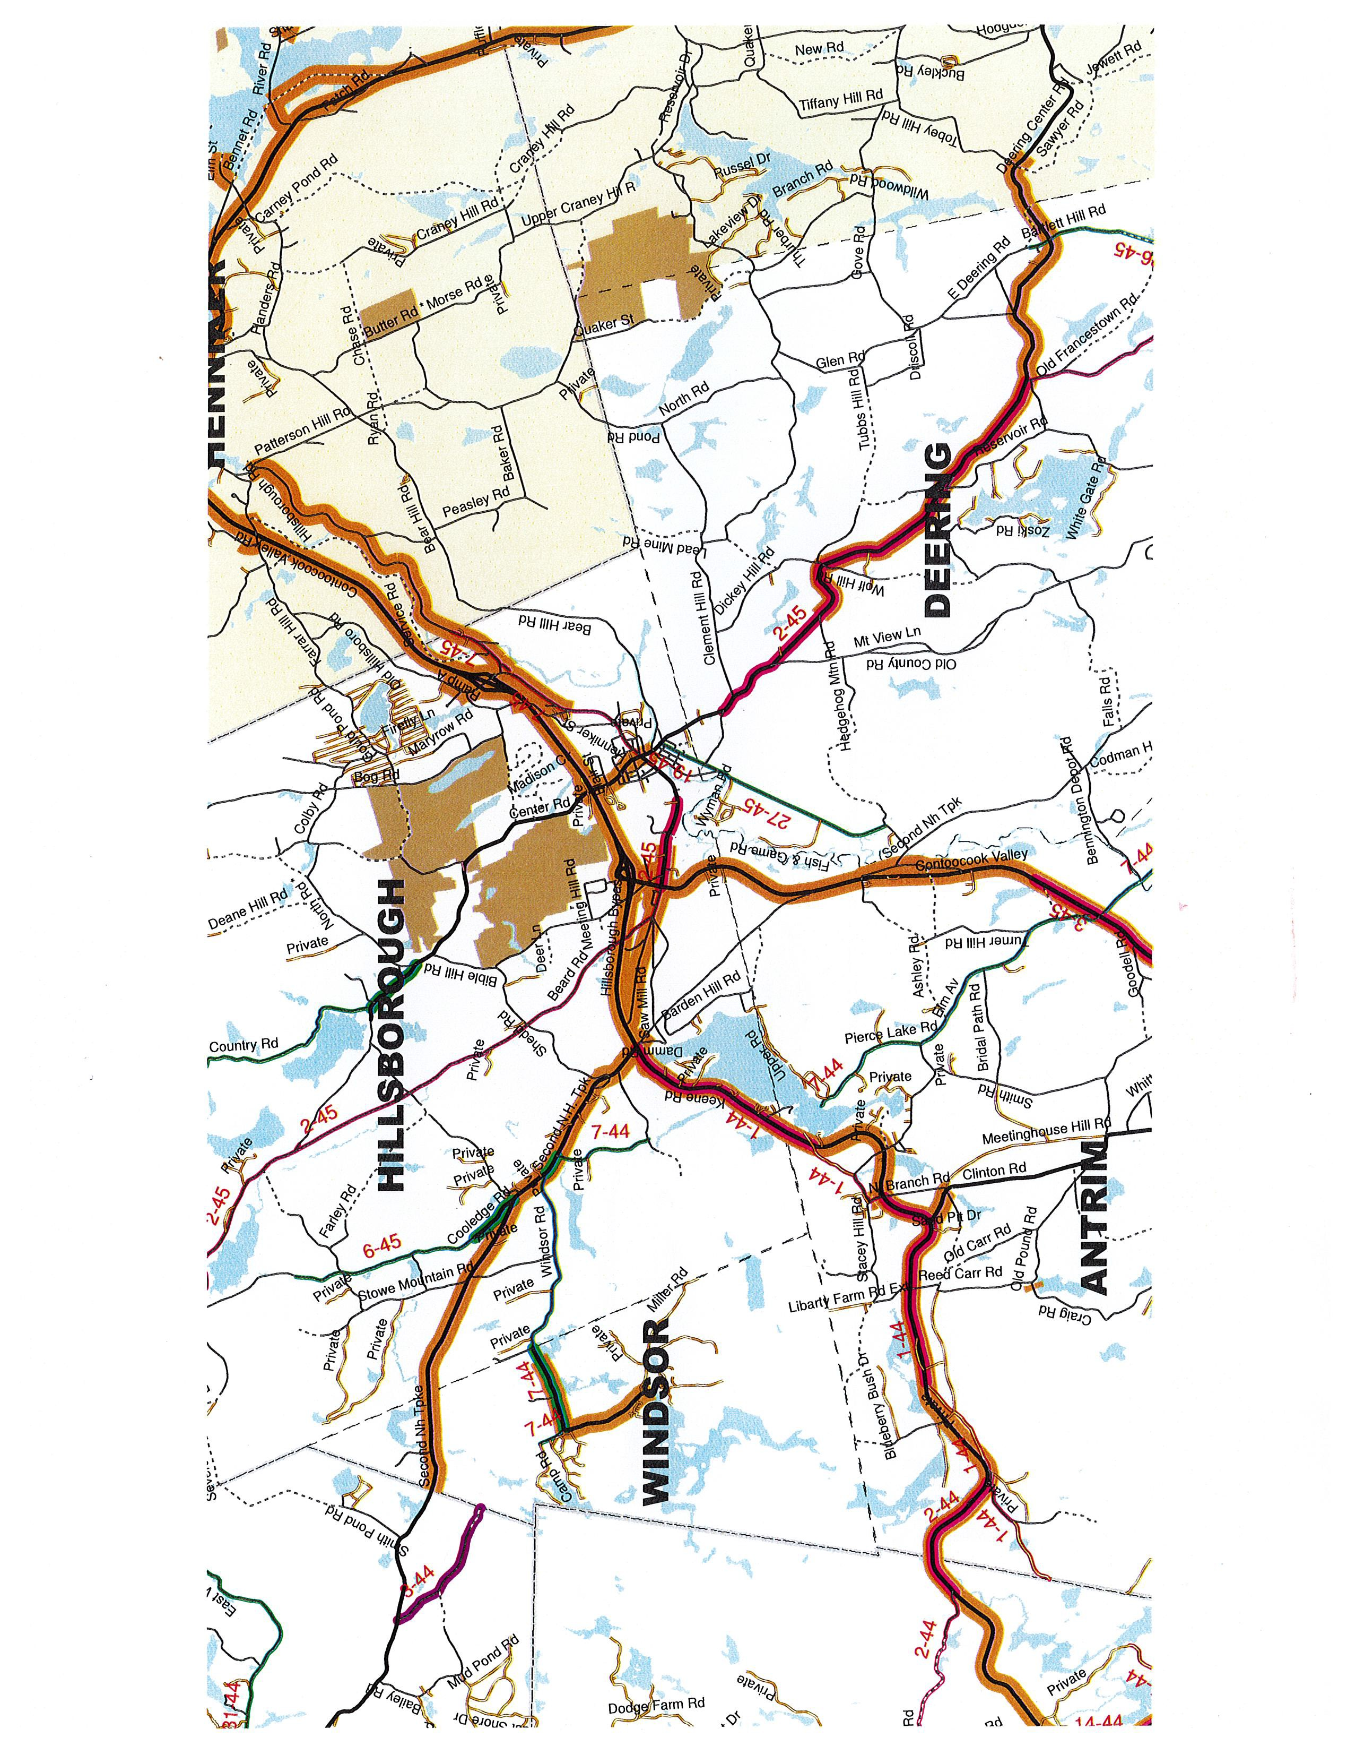

APPENDIX E

EXISTING CONDITIONS PHOTOS

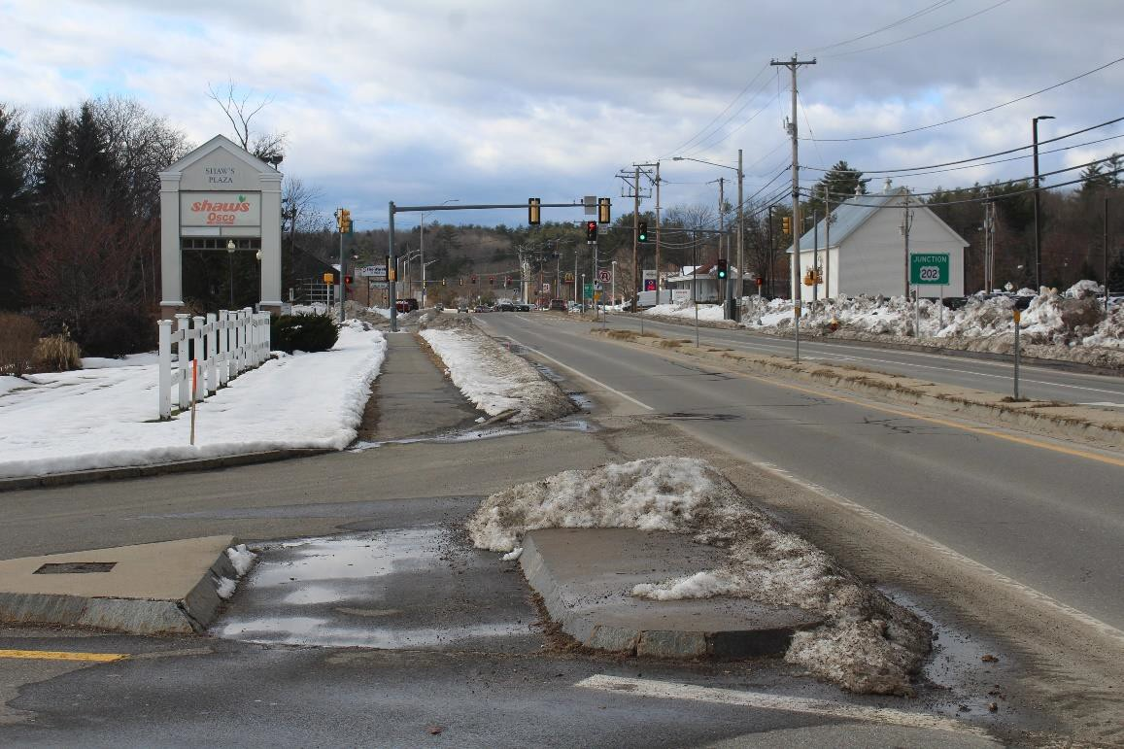

Photo 1: Existing West Main Street, East Side, South End of Project

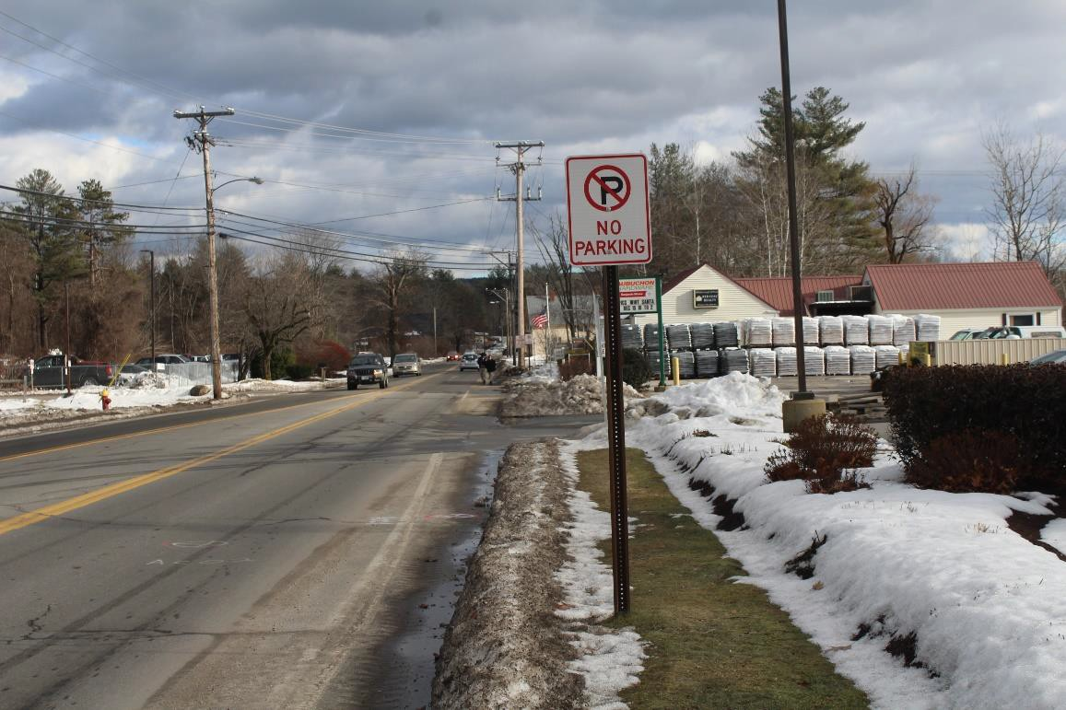
Photo 2: Existing West Main Street, East Side, Near Aubuchon Hardware

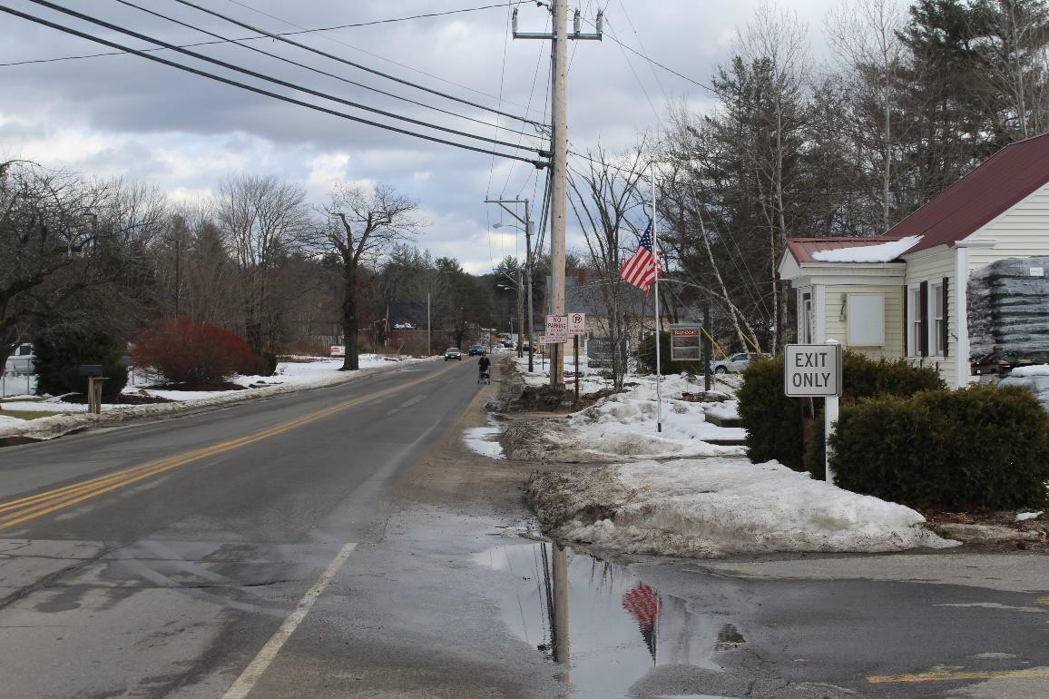

Photo 3: Existing West Main Street, East Side, note pedestrian using East Shoulder

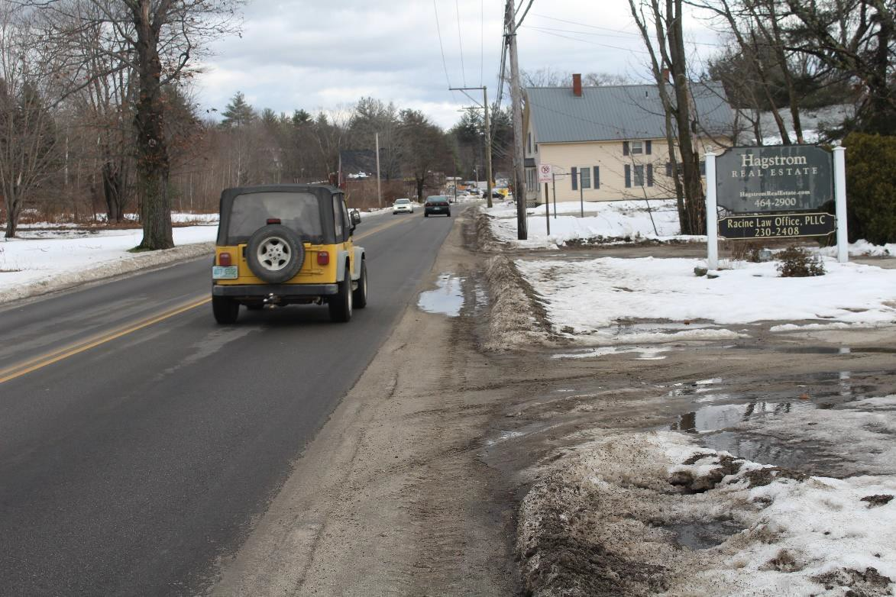
Photo 4: Existing West Main Street, East Side, in front of Hagstrom Real Estate

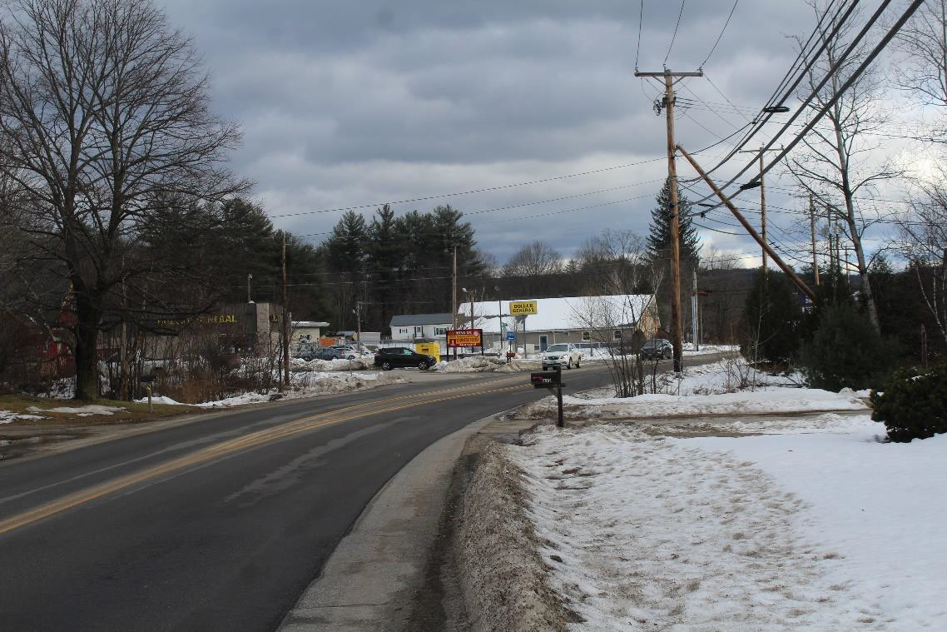

Photo 5: Existing West Main Street, East Side, approaching Municipal Drive

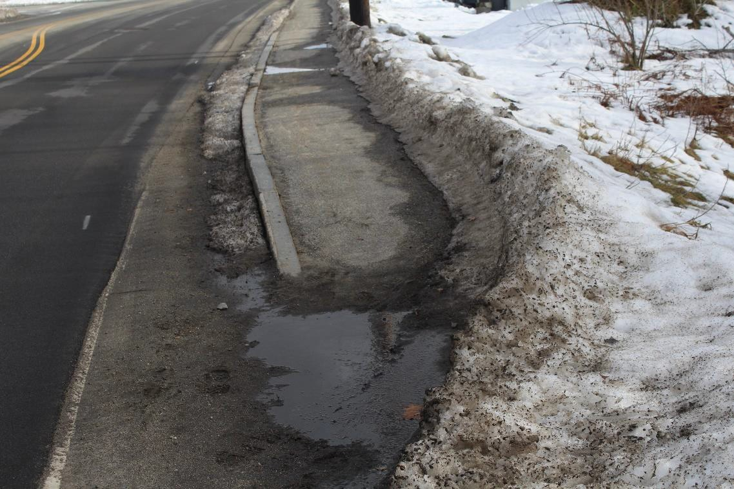
Photo 6: Existing West Main Street, East Side, pedestrian ramp south of Intervale Drive

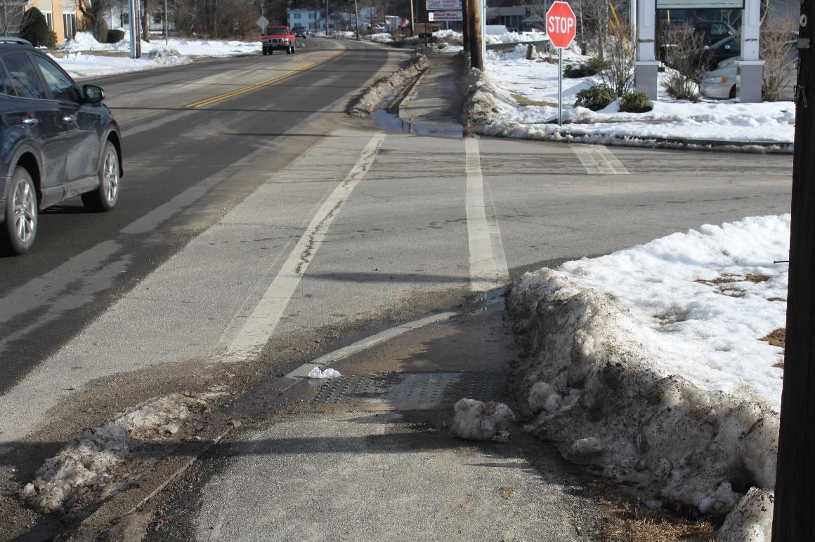
Photo 7: Existing West Main Street, East Side, Intervale Drive crossing

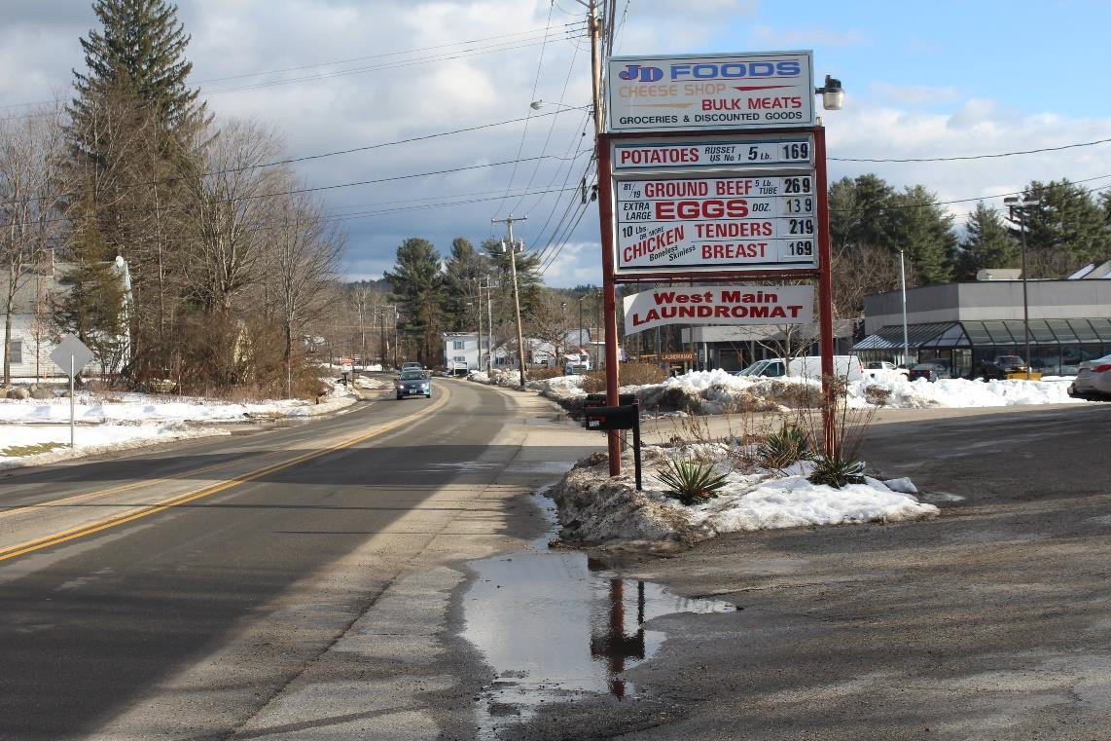
Photo 8: Existing West Main Street, East Side, at West Main Laundromat

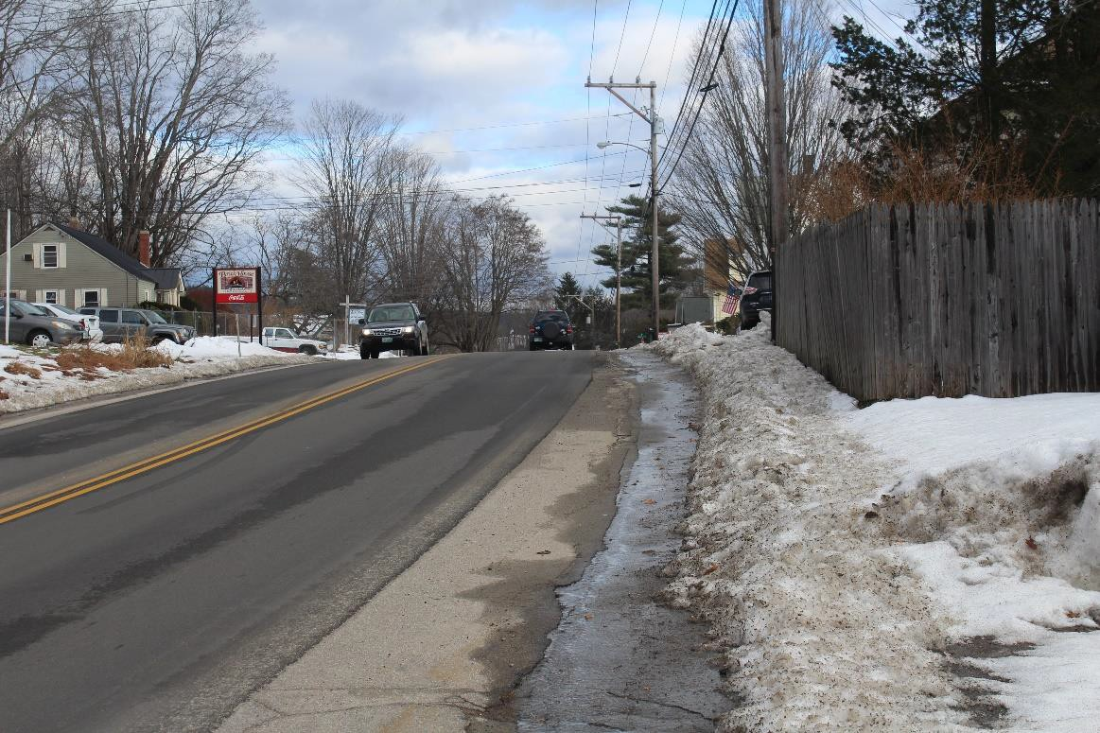

Photo 9: Existing West Main Street, East Side, near Angus Lea Golf Course

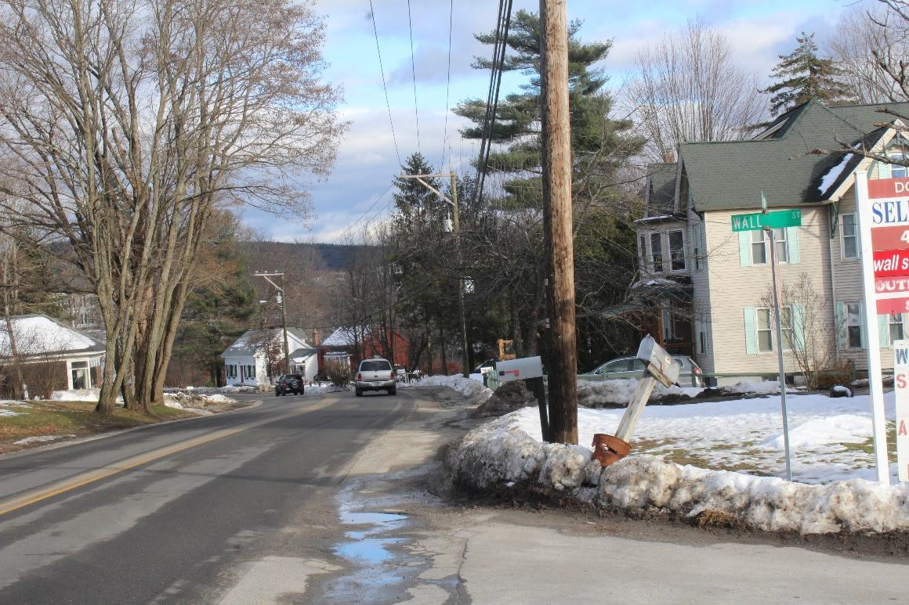
Photo 10: Existing West Main Street, East Side, at Wall Street

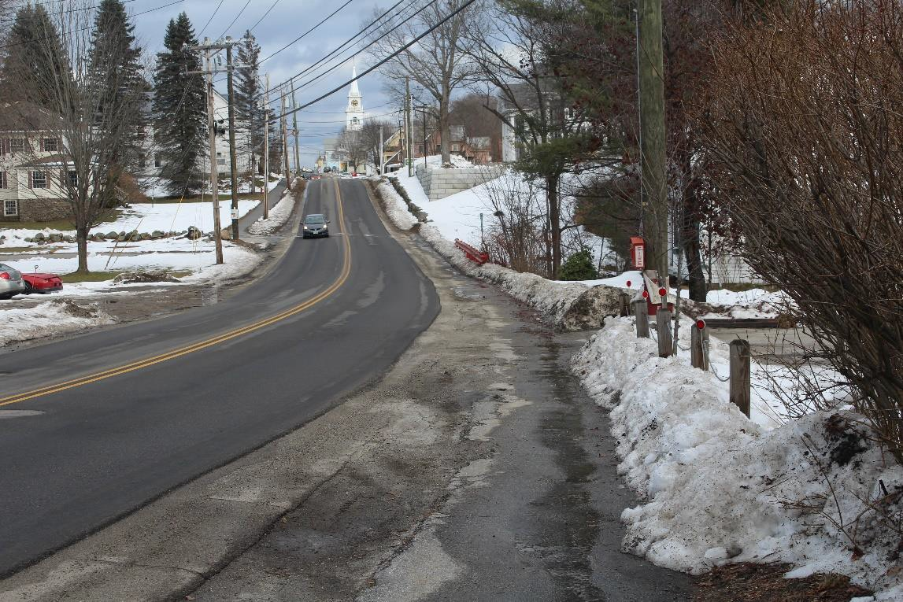

Photo 11: Existing West Main Street, East Side, crosswalk and bridge near northern project limit

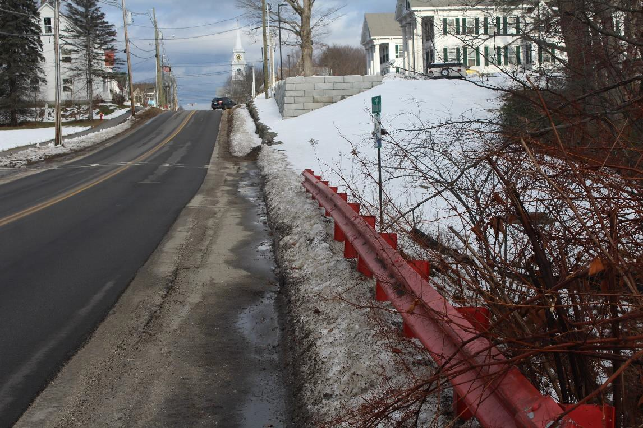
Photo 12: Existing West Main Street, East Side, North end of project

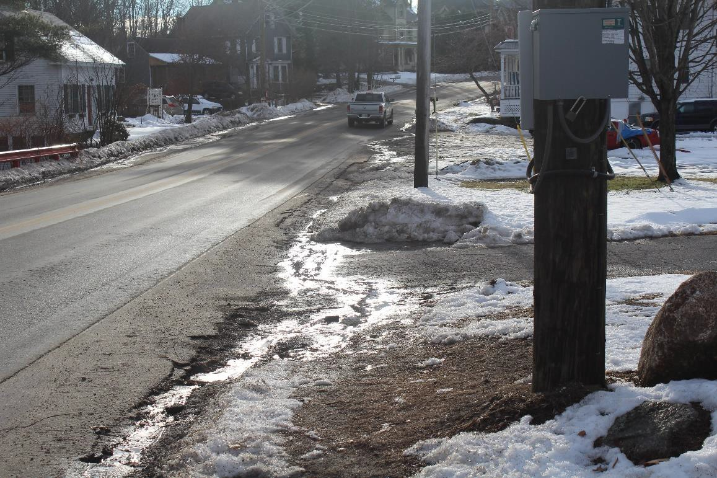

Photo 13: Existing West Main Street, West Side, North End of Project

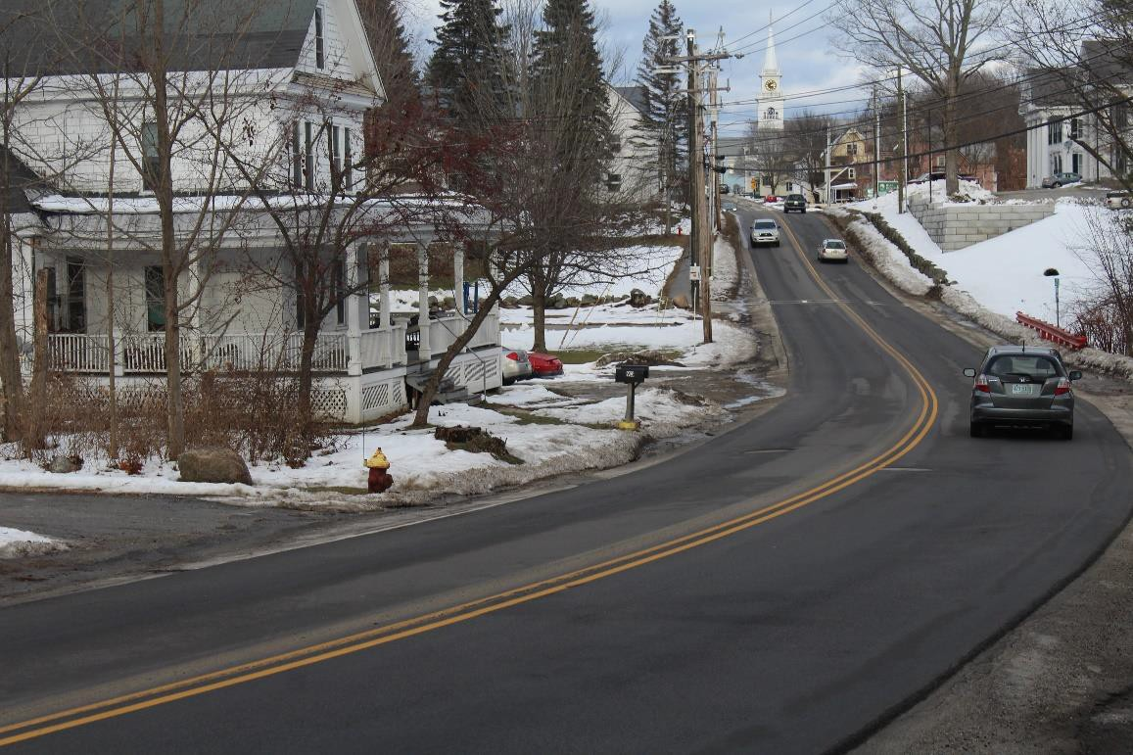
Photo 14: Existing West Main Street, East Side, looking north to End of Project

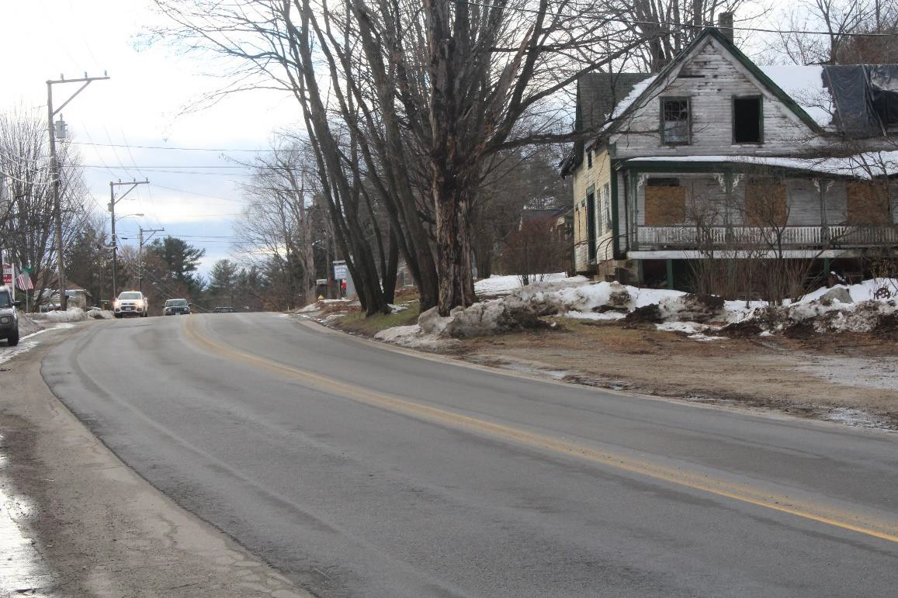

Photo 15: Existing West Main Street, looking North toward Wall Street

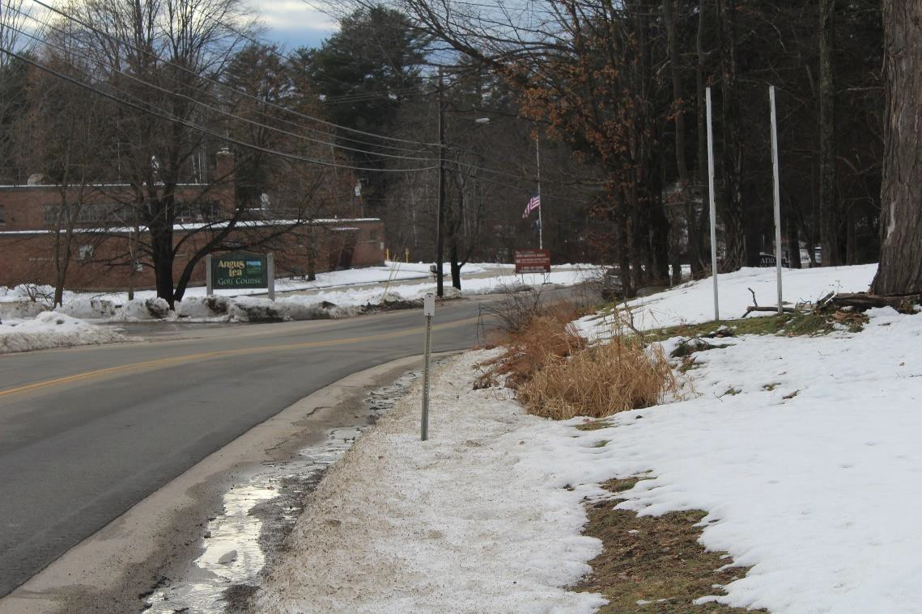
Photo 16: Existing West Main Street, West Side, at Angus Lea Golf Course

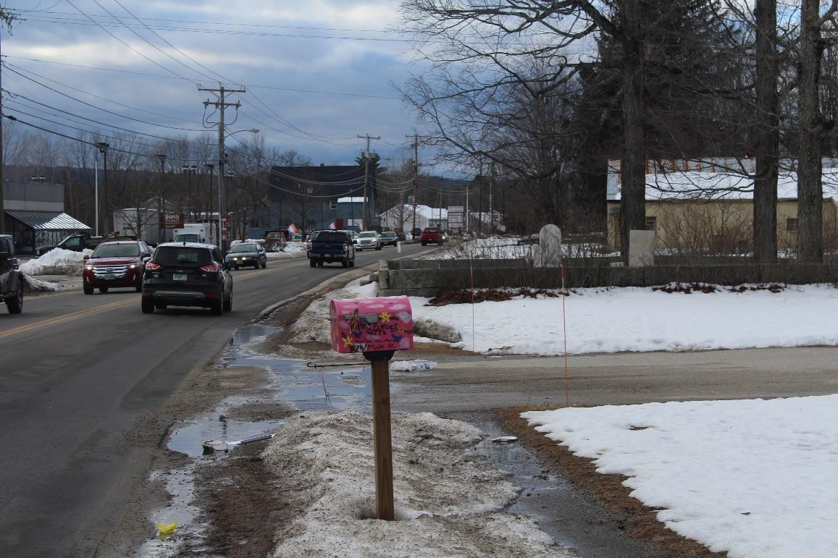

Photo 17: Existing West Main Street, West Side, approaching cemetery

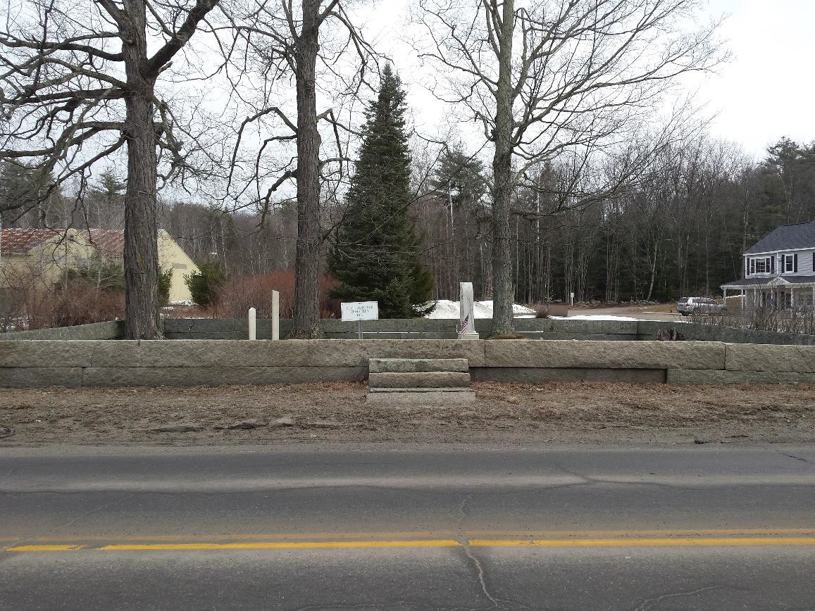
Photo 18: Existing West Main Street, view of cemetery

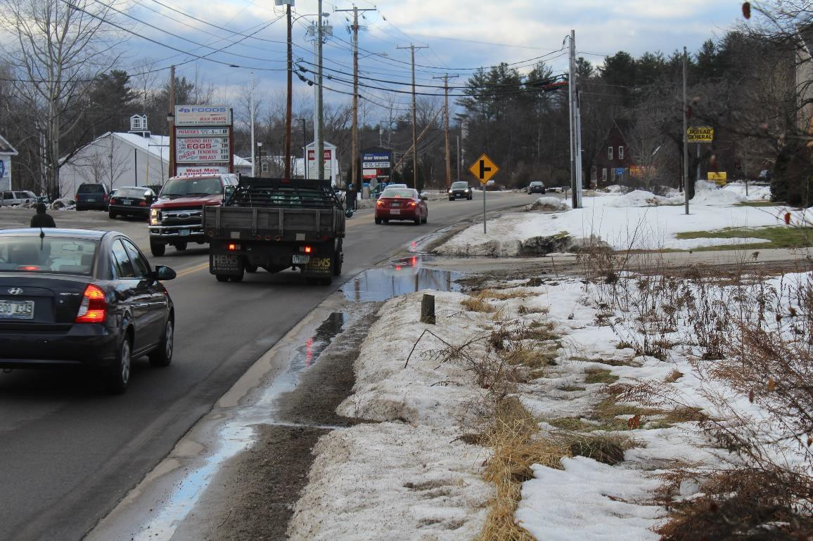

Photo 19: Existing West Main Street, West Side, looking south toward West Main Laundromat

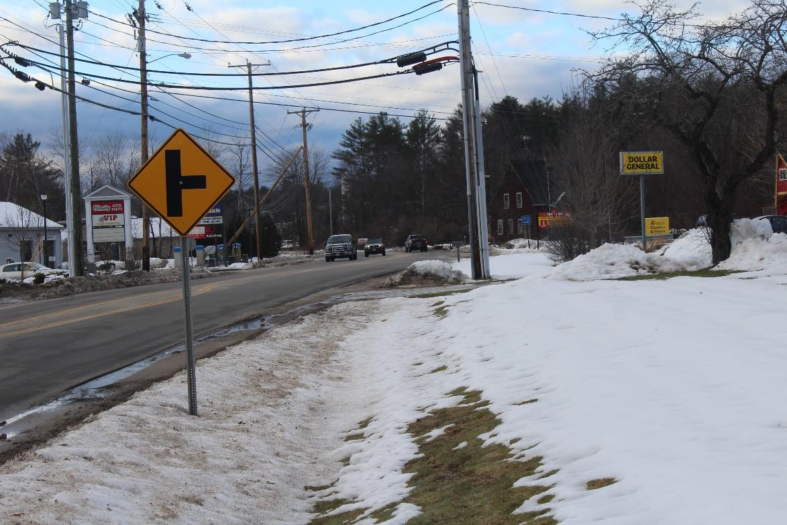
Photo 20: Existing West Main Street, West Side, North of Dollar General

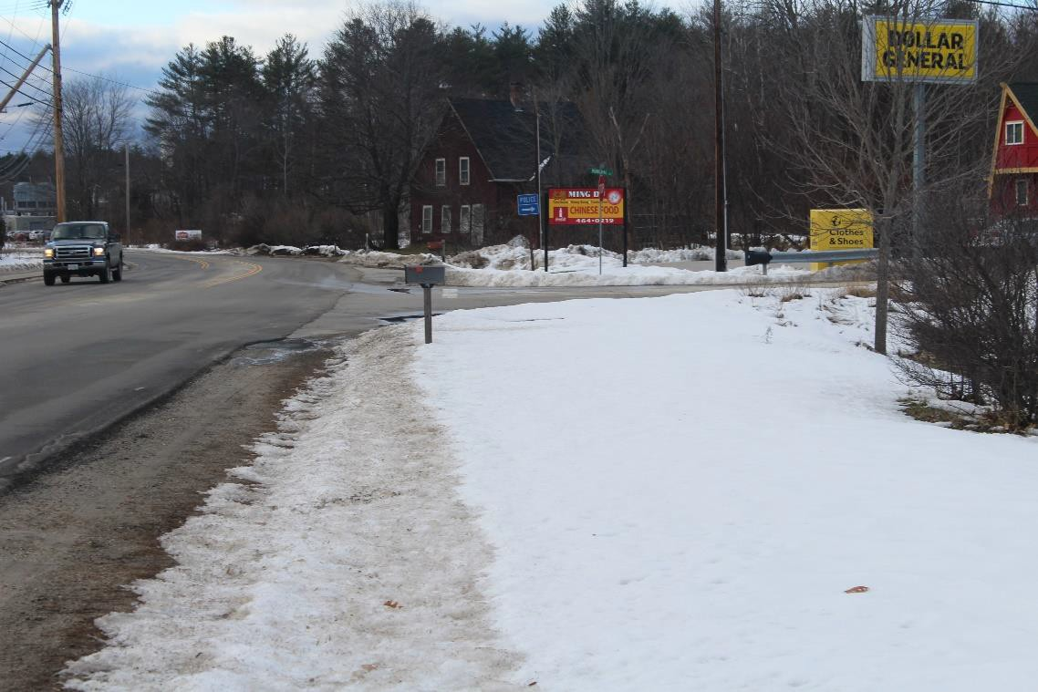

Photo 21: Existing West Main Street, West Side, at Municipal Drive

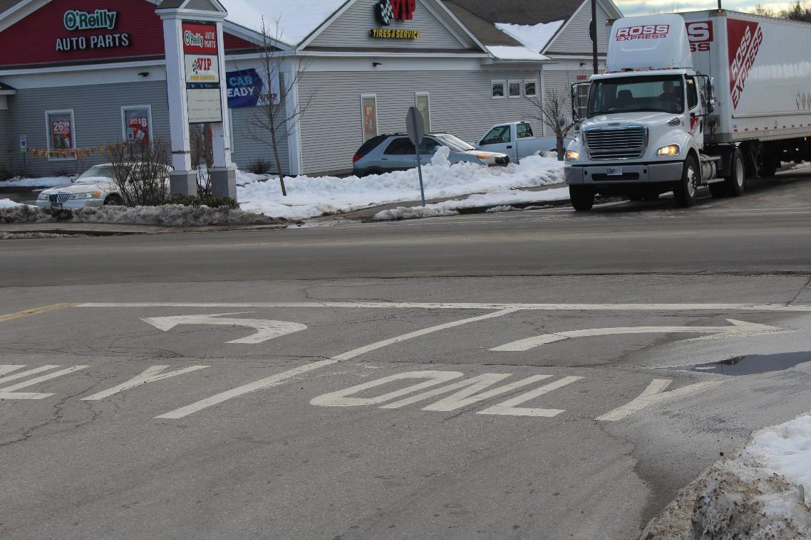
Photo 22: Existing West Main Street, Municipal Drive, looking East

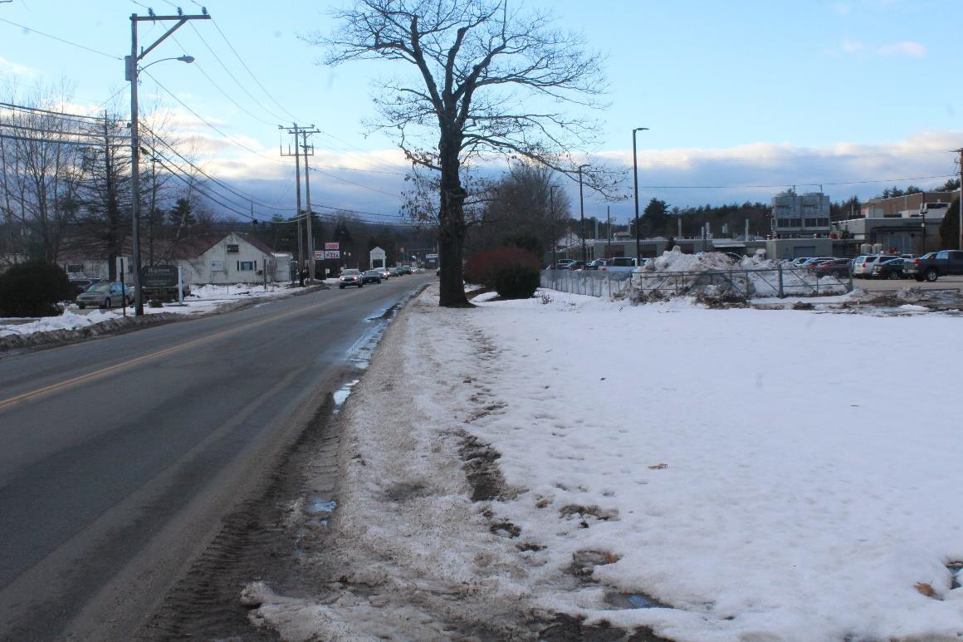
Photo 23: Existing West Main Street, West Side, looking South toward Sylvania

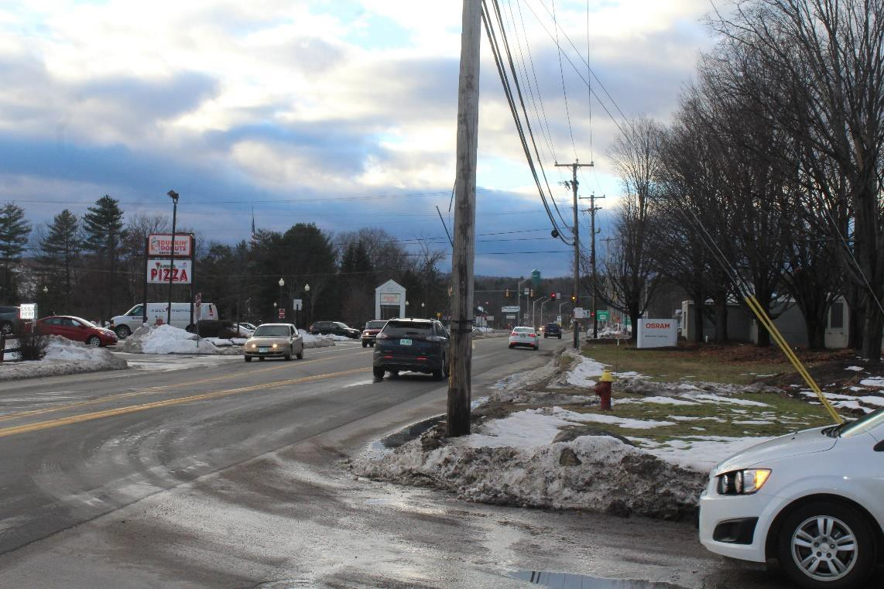
Photo 24: Existing West Main Street, West Side, looking South toward Dunkin Donuts

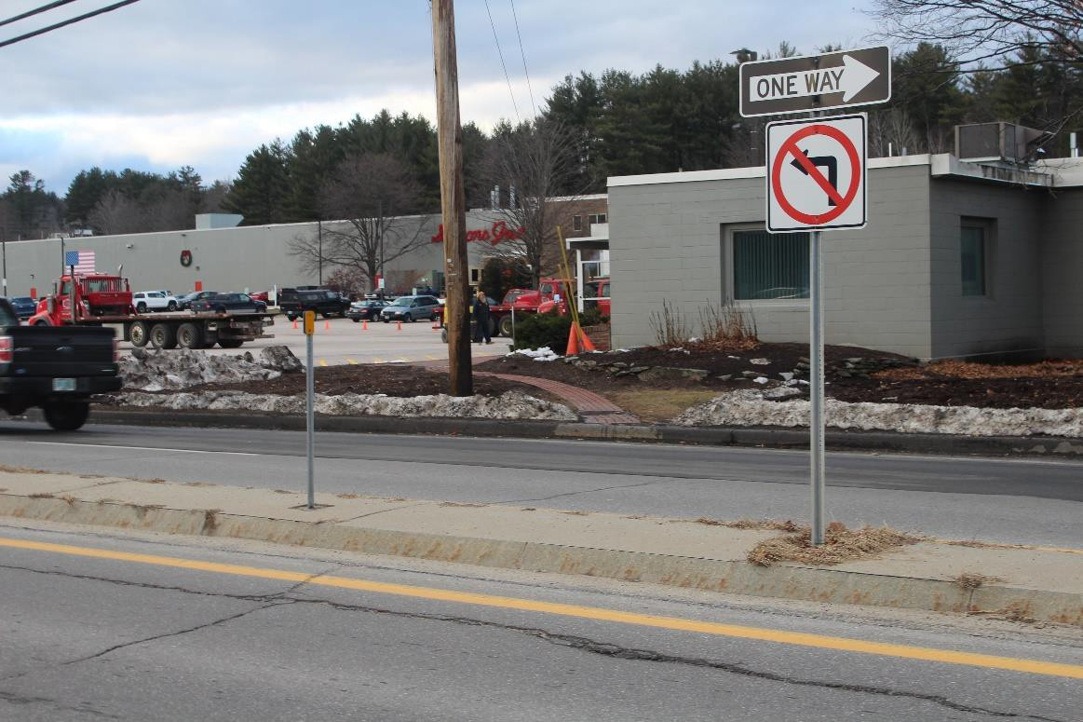

Photo 25: Existing West Main Street, informal crossing between Sylvania and Dunkin Donuts

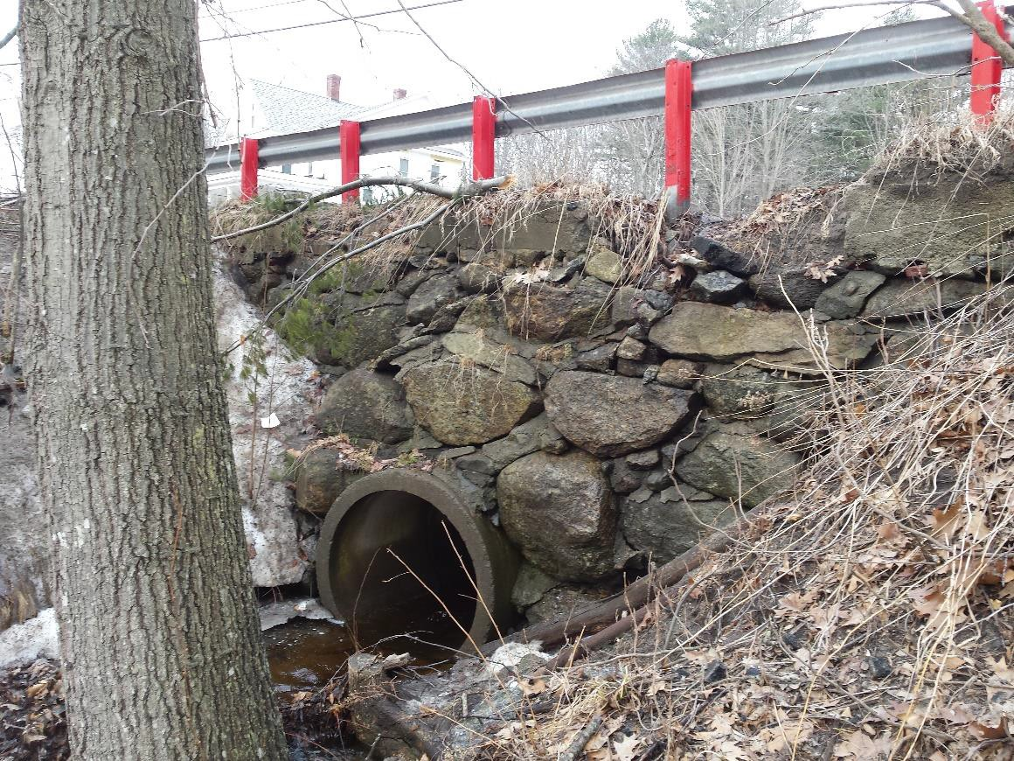
Photo 26: Existing West Main Street, Headwall Evaluation site

